ZBËRTHIMI I KONCEPTIT TË PAJTIMIT NË KONTEKSTIN E KOSOVËS
QERSHOR, 2017
PRISHTINË, REPUBLIKA E KOSOVËS

DECONSTRUCTING RECONCILIATION IN KOSOVO
JUNE, 2017
PRISHTINE, REPUBLIC OF KOSOVO

Titulli: Zbërthimi i Konceptit të Pajtimit në Kontekstin e Kosovës
Autorë dhe kontribues: Nora Ahmetaj, Besa Kabashi-Ramaj, Morgane Jacquot, Yllka Buzhala, Adnan Hoxha;
Përkthyer nga: Artan Sadiku;
Redaktuar nga: Artan Sadiku;
Viti i botimit: Qershor, 2017;
Dizajni dhe shtypi: Europrinty;
Katalogimi në botim – (CIP) 343.21(496.51); Bibloteka Kombëtare dhe Universitare e Kosovës; Numri Ndërkombëtar i standardizimit të librit (ISBN 978-9951-640-08-4); Botim i Qendrës për Hulumtim, Dokumentim dhe Publikim (QHDP). Të gjitha të drejtat e rezervuara. Asnjë pjesë e këtij publikimi nuk guxon të riprodhohet, të ruhet në ndonjë system të ruajtjes së të dhënave apo të transmetohet, në asnjë formë apo mënyrë elektronike, mekanike, fotokopjuese, incizuese apo tjetër, pa pëlqimin paraprak me shkrim nga ana e botuesit.
Botuar nga: Qendra për Hulumtim, Dokumentim dhe Publikim (QHDP)
Rr. Garibaldi, Hyrja 2, Nr. 17, Prishtinë, 10000, Republika e Kosovës; Tel: +377 45 321 545; info@crdp-ks.org; www.crdp-ks.org.
Tirazhi i ekzemplarëve të botuar: 100

Title: Deconstructing Reconciliation in Kosovo
Authors and Contributors: Nora Ahmetaj, Besa Kabashi-Ramaj, Morgane Jacquot, Yllka Buzhala, Adnan Hoxha;
Translation: Artan Sadiku;
Editor: Centre for Research, Documentation and Publication
Published: June 2017;
Design and Print: Europrinty;

Cataloging in publication - – (CIP) 343.21(496.51); National and University Library of Kosovo; ISBN 978-9951-640-08-4; A publication of Centre for Research, Documentation and Publication (CRDP). All rights reserved. No part of this publication may be reproducted, stored in a retrieval, system, or transmitted, in any form or by any means, electronic, mechanical, photocopying, recording or otherwise, without the prior written permission of the publisher.

Published by: Centre for Research, Documentation and Publication (CRDP)
Str. Garibaldi, Entrance 2, No. 17, Prishtina, 10000, Republic of Kosovo; Tel: +377 45 321 545; info@crdp-ks.org; www.crdp-ks.org;
Circulation published: 100

Përmbajtja e këtij publikimi pasqyron pikëpamjet dhe mendimet e autorëve që janë përgjegjës për faktimin dhe saktësinë e të dhënave të prezentuara këtu. Pikëpamjet dhe mendimet e shprehura këtu, jo domosdoshmërisht i paraqesin ato të Charles Stewart Mott Foundation.
The content of this publication reflects the views and opinions of the authors, who are responsible for the facts and accuracy of the data present herein. The views and opinions expressed here do not necessarily represent those of the Charles Stewart Mott Foundation.

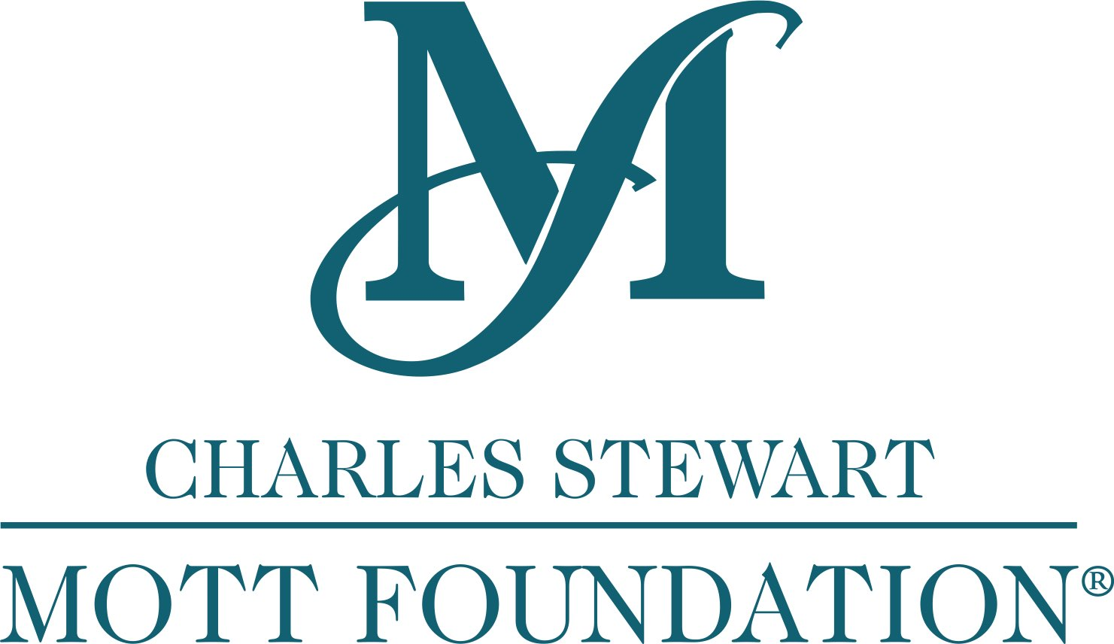

Përmbajtja e këtij publikimi pasqyron pikëpamjet dhe mendimet e autorëve që janë përgjegjës për faktimin dhe saktësinë e të dhënave të prezentuara këtu. Pikëpamjet dhe mendimet e shprehura këtu, jo domosdoshmërisht i paraqesin ato të Ambasadës së Zvicrës në Kosovë.

The content of this publication reflects the views and opinions of the authors, who are responsible for the facts and accuracy of the data present herein. The views and opinions expressed here do not necessarily represent those of the Embassy of Switzerland in Kosovo.

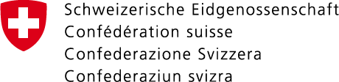

Embassy of Switzerland in Kosovo

Përmbajtja e këtij publikimi pasqyron pikëpamjet dhe mendimet e autorëve që janë përgjegjës për faktimin dhe saktësinë e të dhënave të prezentuara këtu. Pikëpamjet dhe mendimet e shprehura këtu, jo domosdoshmërisht i paraqesin ato të Friedrich Ebert Stiftung.

The content of this publication reflects the views and opinions of the authors, who are responsible for the facts and accuracy of the data present herein. The views and opinions expressed here do not necessarily represent those of Friedrich Ebert Stiftung.

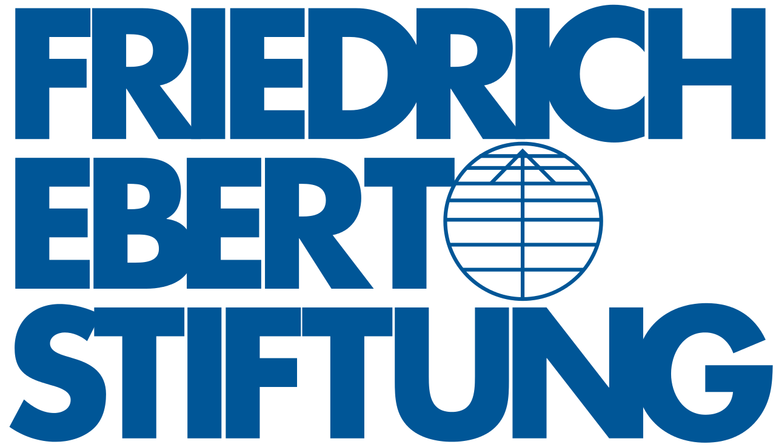

TABLE OF CONTENTS

INTRODUCTION 7

I. LITERATURE REVIEW 9
A global perspective on transitional justice: a few relevant cases 9
Transitional justice in Western Balkans 10
Kosovo characteristics 11
Transitional justice and Reconciliation in Kosovo 13
What has been done in the reconciliation process so far? 14
What worked? 16
What did not work? 16
The reconciliation gap in Kosovo 17
Theoretical framework 18
A theoretical view on Kosovo 20

II. METHODOLOGY 23

III. RESULTS AND DISCUSSION 25
Quantitative research results 26
Source of conflict and mechanism of reconciliation 26
Institutional effectiveness of tackling inter-ethnic issues 31
Existing level of inter-ethnic interaction 31
Prospects of another armed conflict 34
Qualitative research results 36
The concept of reconciliation 36
Qualitative Main Findings 46

IV. CONCLUSION 47

V. REFERENCES 50

Acknowledgements

History has proven that no great work has ever been done without the support of the surrounding environment, partners and professionals. It is in this sense that CRDP would like to thank the following partners and professionals for their support of our Deconstructing Reconciliation in Kosovo project: The Charles Stewart Mott Foundation, a foundation that has consistently supported CRDP and its work in reconciliation and transitional justice, making this whole project possible; The Swiss Embassy Prishtina, who has faithfully supported both phases of this project; and Friedrich Ebert Stiftung, a dedicated partner who has supported both phases of this project. Additionally, we also want to thank the Institute for the Study of Human Rights at Columbia University, as well as McGill University's Center for Human Rights & Legal Pluralism-Faculty of Law for supporting this research initiative. And last but not least, we want to thank Ms. Lauren Pak, our Vanderbilt University provided intern who supported this project in its very inception phase and Ms. Chelsea Cohen, a Fulbright-Clinton Public Policy Fellow, who supported the final stages of this research paper.

ABSTRACT

The purpose of the ‘Deconstructing Reconciliation’ research is to deconstruct the concept of ‘reconciliation’ through the authentic view of the Kosovar population and to call attention on what might be the significant changes to take in order to reach it. To date, the transitional justice and reconciliation process in the Republic of Kosovo is in a paralyzed state and the population is still facing socio-economic difficulties and political instability while ethnic tensions are palpable. To the aim of the project, the methodology used involves both a quantitative approach, to gather data from individuals through a semi-structured questionnaire, and a qualitative approach, done through focus groups.
According to the main findings, important disparities can be drawn between generations over the issue of reconciliation and coexistence. However, the primary tension between Albanians and Serbs remains at the center of a potential reconciliation process. Besides, the results highlight a gap between legislation and implementation of reconciliation processes, and a call from the population to focus on economic development and political stability. The ‘Deconstructing Reconciliation’ research reveals the need for the Republic of Kosovo Government and International Community to develop a bottom-up approach in order to reestablish confidence between the population and state institutions but also to address the Albanian and Serb tensions and to deal with the population’s needs and expectations regarding their socio-economic situation.

Keywords: Kosovo, Albanians, Serbs, ethnic conflict, Balkans, Yugoslavia, reconciliation, transitional justice, security, truth, justice, forgiveness, reparations, armed conflict.

INTRODUCTION

Over the last decades, the field of transitional justice has developed and much discussion has happened on how countries emerging from a conflict address the legacy of gross human rights violations and mass atrocities. In a similar way, the concept of reconciliation increased in importance over the years and it is generally acknowledged that the success of transitional justice is conditioned on how reconciliation is dealt with in post-conflict societies. While there is no universal agreement on what reconciliation is, it may be defined as a process that involves mutual recognition of a common violent past and the transformation of a harmful relationship and behavior to promote a shared future towards sustainable peace (Lederach, 1997; Bloomfield, 2003). Such a process is crucial in Western Balkan countries that have been left economically and politically devastated, with many people traumatized, displaced or still missing after the violent conflicts that occurred during the 1990s. In the Republic of Kosovo (hereafter Kosovo), although the war ended in 1999, the process of reconciliation has not yet been successfully conducted and the country still faces a certain level of ethnic tensions and communities in a state of despair, distrust, and hostility towards each other.
Reconciliation is indeed fundamental in post-conflict situations not only to understand the roots of violence that occurred but also to initiate a deep societal transformation to achieve peace. However, the lack of a common understanding about what exactly reconciliation implies makes it even more difficult to have a common ground on how the process should be implemented in Kosovo.
Some academic researchers have pointed out that reconciliation should be seen as a multi-dimensional process that includes the promotion of different values such as truth, justice, mercy, and peace at all levels of society. Hence, for many of them, the success of reconciliation is based on the development of a comprehensive strategy sustained by both top-down and bottom-up initiatives. Moreover, it should involve political, religious, or ethnic leaders, civil society groups, and non-governmental organizations at a top and middle-range level, but above all, the process must focus on individuals at a grassroots level.
In the Kosovo, despite formal processes including the establishment of The Hague International Criminal Tribunal for the Former Yugoslavia, (ICTY) which was designed to deal with war crimes in the successor states of the former Yugoslavia, and with the focus of the international community in dealing with the past mainly through promotion of criminal justice, transitional justice and reconciliation initiatives have remained somewhat marginal in the political and social life in Kosovo. Indeed, the process has been developed at a top-level approach, valorizing criminal prosecution, administrative reparation, and institutional reforms but has failed to involve the communities and population so far. Furthermore, the recognition of the past is mainly controlled by the government and fails to promote truth and pacify ethnic tensions. The need for this research comes from the fact that there is no common understanding of what reconciliation in Kosovo and the Western Balkans is – both etymologically and empirically. The lacks of official or unofficial publications that address reconciliation strategies in a regionally appropriate or critical way further point to the need for the development of an authentic/own regional understanding. It is important to address the topic with a conceptual approach on different levels as well as with a different set of stakeholders.
To address the academic gap in understanding what reconciliation means for its main carriers, the people of Kosovo, this research paper aims to find a Kosovar specific understanding of reconciliation and its prevalent concepts. For the purpose of this study, it appeared necessary to develop a concrete database in order to know how ethnic groups and individuals in Kosovo foresee reconciliation, based on their own experiences and specificities. The research paper has been designed to provide a new approach for the process in Kosovo, by focusing on a grassroots understanding of reconciliation. According to the results, the ‘Deconstructing Reconciliation’ research will try to establish a set of recommendations to complete the strategy developed so far and to address adequately the reconciliation objective.
Chapter 1 will look at the literature on reconciliation that provides theoretical understanding of the nature, the actors, and the dimensions the concept encompasses. Some of the main cases of transitional justice will be explored to give a more concrete vision on how reconciliation has been addressed in the world but also in the Western Balkans so far. Finally, considering what has been done in Kosovo, the study will aim to determine which theory is the most relevant in regard to the current situation.
Chapter 2 will look at the methodology followed in order to deconstruct the concept of reconciliation through a combination of qualitative and quantitative methods. The qualitative approach is based on in-depth interviews, based on four groups of questions regarding: first, the concept of reconciliation and mediation of international organizations; second, the alternative mechanisms of healing the wounds and mediation, reparations, and apology; third, the respondents’ level of institutional trust regarding national and international judiciary; and fourth, the additional mechanisms required to reach reconciliation. The quantitative approach was designed to gather more extensive data from randomly selected individuals through a semi-structured questionnaire based on three main groups of questions regarding the demographic dimension, perception of reconciliation over the socioeconomic environment, and the understanding of reconciliation and forgiveness.
Chapter 3 will focus on the results and discussions from the quantitative and qualitative approach. The results will highlight that the meaning of reconciliation differs depending on the gender, age, and the socio-political level of the individuals, but above all, depending on the participants' understanding of their own ethnicity and the interactions between the ethnicity of the forgiven and the forgiver. They will demonstrate that tensions between Kosovar Serbs and Albanians are still at the center of on-going tensions and that fear of conflict resurgence are still on their minds. Furthermore, it will be stressed that low inter-ethnic cooperation, lack of confidence on international and national institutions, and the gap between policy frameworks and effective implementation regarding the work on both memory and the economic and socio-political aspects are seen as challenges for the reconciliation process.
Chapter 4 will lay out the main conclusions of the study. It will go over the principal aspects the research has highlighted and how, in a more general way, the process should now evolve to include the people of Kosovo as the main carriers of any possibility to reconcile.

LITERATURE REVIEW

A global perspective on transitional justice: a few relevant cases

Several cases of transitional justice have occurred in the last decades, each of them addressing reconciliation in a different way based on its societal, historical, and political specificities but also on the roots of the conflict and the way it ended.
The South African case might be the most famous experience of transitional justice, especially in regard to the notions of forgiveness and truth that have been placed at the center of the process (Bloomfield, 2003). In this society where religion is omnipresent, the process, mainly through the Truth and Reconciliation Commission (hereafter TRC), was based on a restorative justice approach and a communitarian concept of reconciliation (Ubuntu meaning “humanity towards others”) and promoted by religious leaders such as Desmond Tutu. Nevertheless, if the value of forgiveness was central in the process, for some people, the Christian understanding approach was more oppressive than anything else since it was perceived not as an individual process and personal power to give or withhold it but more as an obligation to offer forgiveness (Bloomfield, 2003). Moreover, the possibility to grant amnesty to those ready to make full exposure of facts (Skaar, 2013) reveals that the South African process, to promote healing and reconciliation, rested more on the discovery of truth, that is the “acknowledgment of wrong and the validation of painful loss and experiences” (Lederach, 1997, p.9), which was designed through the testimonies of the victims within the TRC (Andrieu, 2012), than justice (Brounéus, 2003).
The Rwandan Genocide, which took place from April 1994 to July 1994 between the Tutsi and the Hutu ethnic groups, was exceptional both in the gravity of the crimes committed and in their extent. The first approach promoted by the international community was to set up the International Criminal Court for Rwanda (ICTR), in 1994, and de facto, to promote a criminal approach that quickly demonstrated its limits (Andrieu, 2012). Hence, the strictly criminal justice strategy developed by the Rwandan Government was criticized regarding the slow progresses, the treatment reserved to Hutu defendants but also for the general failure of reconciliation (Andrieu, 2012). Faced with the inefficiency of the process, a more community-oriented approach was chosen with the reintroduction of the Gacaca, an ancient dispute resolution mechanism from the 15th century (Gacaca Community Justice, n.d.). The aim of the Gacaca was to help the resolution of the numerous amount of cases that needed to be addressed, to deal with the perpetrators of less serious crimes and to promote the reintegration at a local level (Andrieu, 2012; Brounéus, 2003). The reconciliation process faced several challenges because the Gacaca were perceived by some as traumatic due to the “highly emotive and divisive nature of testimony during hearings” that were held in public with the presence of the victims, perpetrators and their families (Clark, 2010, p.28). Moreover, they were criticized for promoting “one-sided justice” (Clark, 2010) through a chosen narrative against the Hutus, described as the only and main perpetrators of the genocide against the Tutsis. Hence, going further the ethnic groups’ tensions was the main challenge for reconciliation in Rwanda. Nevertheless, the process promoted throughout the Gacaca helped to unclog the courts and to establish a collective memory (Skaar, 2013).
In the late 1990s, different national reconciliation processes have been followed in post-military/authoritarian societies that have been afflicted by civil and political conflict (Loveman & Lira, 2007). In Chile, the repressive and violent General Augusto Pinochet’s dictatorship was followed by the creation of the first Truth and Reconciliation Commission to officially use this name. Designed to reveal the truth of the grave events that occurred and to understand their roots and consequences, the Truth and Reconciliation Commission aimed not only to identify and reintegrate the victims as well as provide them reparations, but also to propose legal and administrative solutions to be adopted in order to avoid repetition of the past. Closely related to the social, cultural, and political realities, the Chilean reconciliation experience is recognized as one of the most successful (Hourquebie, 2014). The whole process was designed over the will to rebuild the country “together” and to avoid revenge.
The process followed in East Timor is a relevant case too because the adopted strategy rested on the use of the pre-existing power structures (Skaar, 2013). The Commission for Reception, Truth, and Reconciliation intended to reintegrate individuals using traditional judicial codes and mechanisms for less serious crimes. By going further than the symbolic and religious aspects of the TRC in South Africa (Andrieu, 2012), the approach chosen for East Timor was a more integrated one, attempting to deal with several aspects such as culture, justice, politics, and psychology (Brounéus, 2003). The process particularly focused on the restoration of autonomous and functioning state institutions, with the work of the United Nations Transitional Administration in East Timor (UNTAET) that was in charge of the interim civil administration and peacekeeping missions in the territory of East Timor since 1999.
Different approaches may indeed be taken. These cases show that developing a judicial international mechanism has been seen as a first step to take to reach reconciliation, as it occurred in Rwanda or Former Yugoslavia, while some other processes center more on the creation of Truth and Reconciliation Commissions (Rwanda, South Africa, Chili, Canada and so on) or on the use of traditional mechanisms to reach reconciliation and develop a truly bottom-up approach (Rwanda, Burundi, Uganda).

Transitional justice in Western Balkans

In the 1990s, Former Yugoslavia was at the center of a brutal and violent war, leaving the Western Balkans in a state of trauma and destruction. The heinous conflicts that occurred in the region were characterized by atrocities such as genocide, ethnic cleansing, collective rape, and massive numbers of traumatized, displaced, or missing people. More than 15 years after the conflicts ended, the Western Balkans still suffers the effects of the war not only at a political and economic level but also, above all, at an individual human level.
The international presence and initiatives designed right after the end of the conflicts were encouraging. Calling for the establishment of a legal process to address war crimes and gross human rights violations a first step was taken with the creation of the ICTY in the Hague in 1993, in accordance with the UN Resolution 808 and 827. The ICTY and national courts have concurrent jurisdiction to prosecute serious violations of international humanitarian law committed during the conflict. Nevertheless, the ICTY had the possibility to claim primacy if it was in the interest of international justice. Four categories of offences were characterized to be under the Tribunal authority: grave breaches of the 1949 Geneva conventions, violations of the laws and customs of war, genocide, and crimes against humanity (Mandates and Crimes under ICTY Jurisdiction, n.d.). Moreover, in Bosnia, Croatia, and Serbia, numerous initiatives were designed and promoted by international experts to deal with war crimes, to promote the return of refugees and displaced persons, and to reform the security sector and the rule of law. Several attempts to identify state responsibility were made before the ICJ, and in February 2007, on the application made by Bosnia and Herzegovina to judge Serbia and Montenegro for breaches of the UN Convention on the Prevention and Punishment of the Crime of Genocide, the ICJ held that genocide occurred in Srebrenica. However, Serbia was not found accountable. Moreover, several attempts have failed so far to establish sustained cooperation between the countries of the region to create a Truth and Reconciliation Commission, tainting the efforts to establish the truth on the conflict events (Fischer, 2013; Application of the Convention on the Prevention and Punishment of the Crime of Genocide (Bosnia and Herzegovina v. Serbia and Montenegro), 2007).
Nevertheless, in 2008, a group of NGOs from Serbia, Croatia, Bosnia and Herzegovina, and Kosovo initiated the establishment of RECOM - the Regional Commission for the Verification of Facts on War Crimes and other serious violations of human rights committed in the territory of the former Yugoslavia from 1 January 1991 to 31 December 2001. This extrajudicial body was intended to investigate allegations of all war crimes and other serious human rights violations related to the war. Unfortunately, the initiative has faced several problems that taint the functioning of the process, especially in regard to the lack of cooperation of the concerned states on the conceptualization of what reconciliation should be beyond the region, (Touquet & Vermeersch, 2016). To date, it has not provided a sustainable answer to the issue of reconciliation in Western Balkans.

Kosovo characteristics

The Republic of Kosovo is a multi-ethnic state in the Western Balkans (Milo, 2006) that has been affected by a long history of its predominately Albanian population, change, influences, wars and disruptions within its territory for many centuries. Many foreign influences and ethnic groups besides the Albanians, such as Bosnians, Serbs and Turks have influenced the current identity of Kosovo throughout years. However, the contemporary issues and challenges the country faces have primarily been the result of the complex relationship and painful past between Albanians and Serbs (Morozzo della Rocca, 2015). Significant differences can be drawn between the two ethnic groups regarding their language, religion or cultural aspects. Thus, their ethnic legacy embodies an essential concern in the context of transitional justice and reconciliation (Morozzo della Rocca, 2015).
The majority of the population in Kosovo is of the Albanian ethnic group, whose presence is meaningful all over the Western Balkans in countries such as Albania as well as in Macedonia Montenegro, and Serbia. The Albanian ethnic group represents the majority of the population in Kosovo and, according to the 2011 Kosovo census (which omits North Kosovo: North Kosovska Mitrovica, Leposavić, Zubin Potok, and Zvečan), the Albanian population is approximately 1, 616, 869 (92,9%). The historical and traditional legacy of the ethnic group alone represents a huge and determinative dimension of the current understanding of Kosovar identity. Their history has been marked by many geostrategic changes within the region and external influences that participated in the eventual splits and shifts of this population. Despite many historical events, the Albanian culture and language, which is also composed of different dialects, remains a common characteristic of this ethnic group. It embodies a significant aspect of the Albanian identity since it defines who is an Albanian “be they from Kosovo or from Albania or from anywhere else” (Judah, 2008) while the other nations in the Balkans are generally defined by their religion. The religious aspect does not play a fundamental role within the ethnical group identity, however, Kosovo Albanians are mostly Sunni Muslims; a minority, especially in Montenegro, is Catholic, and few Kosovo Albanians are Orthodox (Judah, 2008). The Albanian culture encompasses a mighty customary law tradition with codes such as the Kanun Lek Dukagjini or the Kanun of Skandeberg (Arsovska & Verduyn, 2007) whose importance, practice, and influence vary by regions. To date, they still have a particular resonance within the Albanian culture since some precepts continue to be applied even if the authority of the customary law has declined. Hence, Albanians from Kosovo stay relatively close to the whole Albanian ethnic group legacy but the particularities that have been developed within the ethnic group of the country remain significant in the Kosovo context, especially regarding to their relationship with the Serbian population.
The Serbian ethnic group is the largest ethnic minority in Kosovo, and its population is approximately 25, 532 (1,5%), according to the 2011 Kosovo census. The majority of the Serbs are living in Serbia but also in Montenegro, Croatia, and Bosnia-Herzegovina. Within the Kosovar territory, the Serbian ethnic group is mostly located in the North of Kosovo which “remained firmly under Serbian government authority” (Bieber, 2015, p.191). From their perspective, Kosovo’s history has been designed through numerous changes and influences, especially from the Serbs or at least the Orthodox Christian population with whom the Serbs identify (Judah, 2008). The Serbs have not always been just in present day Serbia, and the ethnic group has “moved, shifted, fled, and migrated through the centuries, in and out of Kosovo, and across the former Yugoslav space” (Judah, 2008, P.13). Kosovo Serbs are part of the South Slavonic group of Indo-European peoples and share common characteristics such as Slavic traditions, the Serbian language, or the Orthodox Christian religion. The Serbian language is the official language in Serbia and Bosnia-Herzegovina Republika Srpska, and it is recognized as a minority language in several Western Balkans countries such as Montenegro, Croatia, Slovenia, and the Republic of Kosovo. The Serbian culture is deeply marked by the religious aspect and especially by the Orthodox Christian religion that has played a fundamental role through the history in Serbia and areas were Serbs live, elsewhere in the Balkans (Judah, 2008). This ethnic legacy for the Serbs of the Republic of Kosovo is significant to define their culture, and it is still today particularly relevant in the Kosovo context. Kosovo Serbs are also characterized by both the historical and cultural legacy of the ethnic groups they belong to but also by the complex history that occurred within this region and that defines today the Republic of Kosovo (Bieber, 2015). Hence, the ethnic history and legacy of the Serbian population of Kosovo is a complex one, and these characteristics remain at the centre of the current challenges the country faces.
In recent history, Kosovo became an autonomous province of the Socialist Federal Republic of Yugoslavia (SFRY) in 1974. The subsequent unresolved issues between Kosovo Albanians and the central SFRY government, in light of discriminatory policies towards the Albanian population, the 1990 Serb led vote by referendum for a new Constitution (Bethlehem & Weller, 1997) that removed Kosovo’s autonomy (Judah, 2008; Morozzo della Rocca, 2015) and the abuse of human rights of the Albanian population in Kosovo eventually led to protests, social unrest, and the armed conflict that started in 1998 and culminated in 1999 (Irwin, 2015). With the Croatian and Slovenian declaration of independence in 1991 and the break-up of the Federal Republic of Yugoslavia, the Western Balkans entered a period of a bloody conflict. In 1998 the conflict between Serbian forces and Kosovar Albanians, with the Kosovo Liberation Army (hereinafter KLA), openly started resulting in numerous deaths and missing and displaced persons that alarmed the International Community. It ended with NATO's military intervention, and in June 1999, Kosovo was placed under the UN protectorate (Irwin, 2015). The Kosovo Assembly in 2008 proclaimed Kosovo's independence from Serbia, and to date 113 international countries have recognized Kosovo's independence. While the UN does not officially recognize Kosovo, more than half of the UN member states recognize Kosovo as an independent state (International Recognitions of The Republic Of Kosovo - Foreign Policy, n.d.). This historical-political dimension, however, leaves the current population still divided along ethnic lines between Serbs and Albanians, a relationship that is followed by constant tension between the two sides, culminating in a complicated coexistence between these two communities in particular.

Transitional justice and Reconciliation in Kosovo

At the end of the war, the Western Balkans have been seen as an exceptional case study for the International Community that stressed the need for improving peacebuilding initiatives and a legal process to address war crimes and gross human rights violations (Fischer, 2013). In post-conflict situations, transitional justice mechanisms aim to establish rule of law, ensure accountability by fighting impunity, deliver truth and justice to victims, and promote reconciliation amongst the communities through unearthing the truth about the past injustices (Andrieu, 2012). Regarding the serious crimes committed during the conflict in Kosovo and the on-going issues of the discovering of truth, missing persons, and ethnic tensions, the need to develop transitional justice mechanisms has been judged fundamental to sustain peace and state building efforts (Istrefi, 2016). Transitional justice initiatives have been explored in Kosovo, but the situation remains more complex than it appears and the efforts to reach reconciliation face several issues. The lack of political will and weak improvements of the important legal framework adopted so far, the ethnic-nationalist tensions that remain central in the Kosovo society, and the weariness and loss of confidence in the initiatives and the international community are some of the challenges confronting the reconciliation process.

What has been done in the reconciliation process so far?

Since the NATO intervention in 1999, and especially after the declaration of Kosovo's independence in 2008, attempts towards reconciliation between the Albanian and Serbian communities have been initiated via institution building and in the establishment of the relevant legislation. Police and military strategies, implementation tools and concepts for peace building, have been set up and managed by different actors such as NATO, the UN, and the EU (Daxner, 2010). At an international level, the ICTY has been created to deal with war criminals and to reach reconciliation under a judicial dimension, and the RECOM project was initiated by several Western Balkans NGOs to establish the facts about the war crimes via a regional approach.
In 2017, a special court for the investigation of crimes committed by KLA members during and after the war in Kosovo is expected to start functioning. The creation of the officially called “Kosovo Relocated Specialist Judicial Institution” was decided between the EU and Kosovar and Dutch authorities. The court is to be physically located in the Hague and to act in accordance with Kosovo laws, in order to ensure justice and the prosecution of war crimes and post-war killings. The functioning of this institution is based on the work of international judges that will, however, enforce Kosovo laws and provide witness protection. The new court may prove pivotal in finally creating space for an improved Serbian-Kosovar dialogue and to address the human rights atrocities towards ethnic minorities and political oponents. However, in Kosovo some civilians see the establishment of the court as a blow to their lived experiences because legal reparations still have not been provided when it comes to bringing Serbian perpetrators to justice during the ICTY process (Kosovo Court to be established in The Hague, 2016).
Furthermore, international actors have also valorized several initiatives. The UN Security Council Resolution 1244/1999 placed Kosovo under the United Nations Interim Administration Mission in Kosovo (UNMIK) to sustain a transitional administration and to resolve the serious humanitarian situation. At the same time, the NATO-led Kosovo Force (KFOR) was created to discourage a resumption of hostilities, demilitarize the Kosovo Liberation Army, support international humanitarian action, and to create and maintain a safe and secure environment for Kosovo. Furthermore, in order to assist judicial authority and law enforcement in Kosovo, the UN established the EU Rule of Law Mission in Kosovo (EULEX) that became operational in 2009 (Irwin, 2015; Nato’s role in Kosovo, 2017).
The national strategy designed several initiatives at a political level. A first aspect of the process appeared on the Ahtisaari Plan, formally the Comprehensive Proposal for Kosovo Status Settlement, designed under the supervision of the Contact Group of Great Britain, France, Germany, Italy, Russia, and the United States in 2007 to provide guiding principles for resolving Kosovo’s status. The Ahtisaari Plan focuses on maintaining multi-ethnic, non-religious democracy, promoting both Albanian and Serbian as official languages, essential minority and property rights, and an open market with free competition (Galluci, 2011). Dealing with the past and the concept of reconciliation are included in the Ahtisaari agreement. Article 2 on “Human Rights and Fundamental Freedoms” obliges Kosovo institutions and its citizens to promote the process of dealing with the past. Article 2.5 states: “Kosovo will promote and fully respect the reconciliation process among all communities and its members. Kosovo will create a comprehensive approach with a special emphasis on gender, to deal with the past, which includes a wide range of transitional judicial initiatives”(Comprehensive Proposal for Kosovo Status Settlement, 2007). Nevertheless, state institutions have so far not been encouraged to prioritize transitional justice and to apply Article 2.5 of the Ahtisaari Plan (Daxner, 2010). Concerns about the lack of tolerance from government institutions to deal with the controversial issue of war crimes persist despite the establishment of the Kosovo Relocated Specialist Judicial Institution in the Hague.
Several attempts to offer reparations to the victims have been tried. In 2000, the Regulation 66 on Benefits for War Invalids of Kosovo and for the Next of Kin of Those Who Died as a Result of the Armed Conflict in Kosovo was adopted by UNMIK to provide benefits to victims and their families. The Department of Health and Social Welfare designed a special fund for eligible beneficiaries, and in 2011, the government adopted the Law on the Status and Rights of the Families of Martyrs, KLA War Invalids and Veterans, and the Families of the Civilian Victims of War, to offer benefits to injured members of the KLA and their relatives (Law on the status and the rights of the martyrs, invalids, veterans, members of Kosovo Liberation Army, civilians victims of war and their families of 2011).
In 2012, Kosovo institutions drafted the negotiations for a Stabilization and Association Agreement Action Plan, which was signed by the Council of Europe and the Government of Kosovo on 27 October 2015 and entered into force on 1 April 2016 (Law no. 05/L-069 on ratification of the stabilization and association agreement between the Republic of Kosovo, of the one part, and the European Union and the European Atomic Energy Community, of the other part, 2015). The idea of the agreement is to create a free trade area and facilitate the implementation of European standards in other areas such as competition, support to the state, and intellectual property. Other provisions are included in the political framework, cooperation in a wide range of sectors, including education and employment, energy, environment, justice and internal affairs. Among other things, the agreement calls for inter-ethnic dialogue and peace building (Stabilisation and Association Agreement (SAA) between the European Union and Kosovo enters into force, 2016).
Due to the troubled past of Kosovo, especially in the context of the conflict between Serbs and Albanians, Kosovo's government in 2012 established an inter-ministerial group to deal with the past and reconciliation. The mandate of this inter-ministerial group is based on the four pillars of transitional justice: truth finding, reparations for victims, right to justice, and institutional reform. Although it was conceived as a project that could bring together different actors to create a strategy for dealing with the past, political and financial support was missing, and this strategy has not developed so far. Moreover, Kosovo remained without a genuine framework for dealing with the past on the basis of which policies would be implemented (Ahmetaj & Unger, 2017).
Some research reports from national and international organizations which monitor the respect for human rights and directly or indirectly relate to reconciliation and transitional justice highlight the adoption of the Strategy and Action Plan on Human Rights (2013-2017), as well as the satisfactory level of involvement of various stakeholders in the processes related to the protection of human rights at the local level. However, there is a lack of greater involvement of minority communities in decision-making and language use despite legal obligations to include them.

What worked?

Thanks to the investment of the international community and its cooperation with Kosovo’s government, a flourishing framework regarding transitional justice mechanisms has been designed. Efforts have been made to approach the Western and European institutions and a first step was taken with the declaration of the Kosovo independence in 2008 and the recognition of the country by numerous states around the world. UNMIK, KFOR, and EULEX have designed several initiatives to sustain the peace building progress, leading to the constitution of a remarkable framework. Furthermore, the ICTY played a significant role for the criminal prosecutions and helped to the drafting of the legislation to design institutions for war crimes prosecution in Bosnia, Croatia, and Serbia (Fischer, 2013). Indicted by the court in 1999, Slobodan Milosevic died before his trial. Nevertheless, in February 26, 2009, the ICTY convicted five senior Serb officials for crimes committed during the war against the Kosovar Albanians in 1999 in the case Prosecutor v. Milan Milutinovic. Since its establishment, the ICTY has charged 161 persons for serious violations of humanitarian law committed in the Former Yugoslavia between 1991 and 2001, and 9 of the most important Serbian and Yugoslav officials were indicted for crimes allegedly carried out in Kosovo by Serb forces (Five Senior Serb Officials Convicted of Kosovo Crimes, One Acquitted, 2009). However, these few significant results of the process in Kosovo highlight that the process designed has not permitted or reached reconciliation so far.

What did not work?

Unfortunately, the strategy adopted so far has rarely managed to get positive results. The ICTY embodies a first fail in the process for reconciliation. Under the direction of the ICTY, justice was applied as solely an individualized affair rather than a collective responsibility, ignoring “the social and political reality surrounding the individual cases” (Touquet & Vermeersch, 2016). Major criticism of the court procedures revolved around the inability to convict the primary perpetrators of the conflict. Many officials were released, and Milosevic died before his official sentence in The Hague. Today, the ruling party of Serbia is the same as the one under Milosevic with cabinet members remaining in power, and, in the same way, Croatia and Kosovo are still dominated by the same types of leaders they had during the wars of the 1990s. The ICTY closure is planned for the 31th December 2017, but the question on whether or not its documentation records will be made publically accessible is still under debate (International Criminal Tribunal for the former Yugoslavia Calls for papers for June 2017 Legacy Conference, 2016).
Concerning RECOM, the initiative has been widely accepted by the progressive forces in Kosovo and the region. However, it did not get the true support of the government in Kosovo and other countries in the region. Indeed, in literature analyzing the RECOM initiative of 2006 in the context of reconciliation, a major criticism was addressed to the Regional Initiative “for putting all victims on an equal footing” in an attempt to be cross regional and to provide a forum for all ethno-national groups (Touquet & Vermeersch, 2016). The lingering discord depicts the unsuccessful resolution of the 1990s conflict and becomes the counterintuitive display of positive peace where “all parties genuinely believe that they are victims of injustice...much of which is institutionalized and also culturally and psychologically internalized”, where Serbia claims victimization and its violent aggression in Kosovo as warranted acts of defense (Ramsbotham, Miall, & Woodhouse, 2011, p.12). However, the RECOM initiative was created in 2006 officially​ discuss about Transitional Justice and Reconciliation issue beyond current state borders. Nevertheless, many victims associate reconciliation with the act of forgiveness, “which they were not prepared to do” (Touquet & Vermeersch, 2016, p.66). Hence, the lack of cooperation and common understanding of reconciliation obstructed the efforts of the RECOM initiative.
Moreover, the institutional denial and unwillingness to acknowledge atrocities at the state-level through labeling of monuments, calendars, commemoration of war heroes versus criminals, and recording of historical events leads to socio-cultural confusion and inability to define historical, collective truth. There is a relationship between how memory, identity, conflict, myth, exclusion, inclusion, and victimization are defined and projected. The conflict’s representation and collective memory have deep socio-psychological ramifications that threaten to continue and fuel greater group identity separation and nationalism. The politics regarding the past prove that the conflict has not been definitively resolved, and the institutional politicization of the past consequently leads to trauma trivialization, avoidance of collective acknowledgment and responsibility, and false consciousness of conflict. The danger of a one-dimensional narrative is shown by how the post-conflict generation who did not experience the wars has a limited perspective leading only further away from the truth and the much-needed acknowledgement for reconciliation (Sweeney & Ahmetaj, 2015).
To date, the Kosovo nation-building process is at a paralyzed standstill. What was supposed to be unanimous international recognition of independence has been dragged out for now close to a decade. As a consequence of this political deadlock, society has been unable to function and reach socioeconomic stability. Politicalized rhetoric has also made it difficult to decipher the actual perceptions and wants of the community. The lack of a unified, agreed-upon definition has made peacebuilding processes difficult to measure for effectiveness.

The reconciliation gap in Kosovo

The efforts designed so far in Kosovo to reach reconciliation have not produced the expected results and the actual situation highlights the lack of concrete and valid understanding of what reconciliation means at a local and regional level. There is a great need for clarity when it comes to reconciliation in order to keep institutions accountable and to track development. Documentation, research, and data are absolutely necessary to build the foundation for a young state in a sustainable truth, and will be used by public, not-for-profit, and the private sector in directing local efforts addressing community needs post-conflict. Exploring theoretical frameworks of reconciliation to develop a concrete approach is now fundamental to adequately address the issue in Kosovo, especially in regard to its cultural specificities and the political, social, and economic dimensions that now make up the country. While reconciliation is currently understood as a crucial measure to recreate stable relationships between former enemies over the legacy of a difficult past, the different theories developed during the last few years however show that the concept is more complex than it seems.

Theoretical framework

In the course of transition from war to peace, societies have to struggle over how much to acknowledge the past, whether to punish perpetrators, and how to recover from past traumas. In addition, how to treat the presence of the perpetrator, the victims, and bystanders after the violence has ended, poses a series of problems. The most common formula puts the two dangers simultaneously, of mourning for the past and forgetting it; whether is it too much memory, or not enough; too much of victimhood or insufficient memorializing of victims and survivors; too much past or too little acknowledgment of the past (Minow, 1998). These joint dangers accompany not just societies emerging from mass violence but also individuals recovering from trauma. Mô Bleeker on the other hand tell us that reconciliation can be achieved when a society can live with a plurality of opinions, races, cultures, and religions and which sees this pluralism as the basis of its identity in a society where each one accepts and acknowledges the suffering of another (Bleeker, 2014).
Nevertheless, many will agree that there is no consensus of the definition of reconciliation. In that sense, there are different conceptualizations of reconciliation. It can be defined as a goal, aspiration, hope, or, to a certain degree, as a utopia. Likewise, some identify reconciliation as the resumption or creation of a friendship marked by trust that goes beyond traditional divisions. To achieve reconciliation, it is expected sometimes that the involved sides show mutual recognition, respect, acceptance, and sensitivity toward the needs and interests of that other side. These sides should mutually detect shared interests and they work on developing trust and building peaceful relations (Bar-Tal & Bennik, 2004).
One of the main academic research workers John-Paul Lederach defends reconciliation as a slow and holistic process that focuses on the redefinition of a relationship. His definition stands on the dual nature of reconciliation, constituted by both “a focus and a locus”. The "focus" embodies the objective of a new and positive relationship whereas the "locus" is the space where former parties meet and express their pains and expectations. There, the expression of a suffering past from all sides should meet the vision of a shared future between former enemies. He argues that if a relationship is commonly at the heart of the conflict, it is also the driving force of a long-term and sustainable solution that must promote truth, forgiveness, justice, and peace.
Another aspect of his theory focuses on the levels of actors involved in the reconciliation process. Political leaders, at the top level, embody the necessary decision making power to improve the peace building process. At a middle level, leaders of the different fields of the society such as intellectual or traditional leaders also have a role to play as the link they represent between the higher and lower levels of the society. Indeed, the actors who play at a very local level, less political, are crucial as they directly influence the population affected by war.
Moreover, according to Lederach’s theory, the concepts of truth, justice, peace and mercy represent four key dynamics in the reconciliation process that have to be met, spoken, and heard in a common space (Lederach, 1997; 2001). The concept of Truth is about revealing factually and objectively the horrific events of the past. John Paul Lederach defines it as “the longing for acknowledgment of wrong and the validation of painful loss and experiences” (Lederach, 1997, p.29). Lederach defines the concept of Justice as “the search for individual and group rights, for social restructuring, and for restitution” (Lederach, 1997, p.29). Therefore, two types of justice can be defined within the Transitional Justice framework: retributive justice that focuses on a procedural approach of the crimes, strictly seen as a violation of law that should be punished, and restorative or reparative justice, which focuses on the nature of the crime and centers on the psychological and social aspect of the violation. Moreover, the concept of Peace, which “underscores the need for interdependence, well-being, and security” (Lederach, 1997, p.29) is understood as the end of human rights abuses and conflicts but also as the construction of a more constructive relationship between individuals and communities. The last concept of Lederach’s theory is Mercy, which is defined as a shared and future-oriented view “which articulates the need for acceptance, letting go, and a new beginning » (Lederach, 1997, p.29). From a more holistic point of view, mercy includes the notion of compassion and forgiveness toward all suffering individuals but also for the society.
Nevertheless, the relationship between mercy and forgiveness can be defined by contrasting the two concepts. For Jeffrie G. Murphy, mercy is less personal than forgiveness, since the one that usual grants mercy, a judge for example, typically will not be a victim of wrongdoing, and therefore will not have any feelings of resentment. In general, there is a sense that only victims of wrongdoing have the right to forgive (Murphy, 1999). Therefore, mercy has more a public behavioral dimension (Murphy, 1999). Murphy provides an example of forgiveness without reconciliation with a situation where a woman has been repeatedly beaten and raped by her husband or boyfriend. This woman—after a religious conversion, might decide to forgive her batterer –which means to stop hating him without a willingness to resume her relationship with him. “’I forgive you and wish you well’, can, in my view, sit quite consistently with ‘I never want you in this house again.’ In short, the fact that one has forgiven does not mean that one must also trust or live again with a person” (Murphy, 2012, p.8). Furthermore, it is important to make a distinction between forgiveness, as an intrapersonal event, and reconciliation, which according to Murphy is defined as restoration of trust after a breach in that trust. Reconciliation involves dynamic talks about the transgression and forgiveness. It is a separate issue than that of forgiveness. Although they are related to each other and there is a psychological relationship, they are still different.
The theory developed by Daniel Bar-Tal focuses on the psychological aspect of reconciliation and is characterized by a transformation of the relationship between former enemies (Bar-Tal, 2008). To reach reconciliation, all parties have to develop a relationship based on mutual recognition and acceptance of each other in order to reinforce peaceful relations, trust, and positive attitudes regarding the other’s party interests. For Daniel Bar-Tal, the transformation for a peaceful relationship requires “changes in the socio-psychological repertoire of group members in both society” (Bar-Tal, 2008, p.365). In other words, the fundamental requirement is a deep understanding of the causes of the conflict and of the need to transform the relationship, a psychological foundation shared by all members of both societies (Bar-Tal, 2008).
Karen Brounéus developed a theory whereby reconciliation is a societal process that involves a change in emotion and attitude regarding both parts of the conflict (Brounéus, 2003). It is understood as a process rather than a goal to achieve in order to rebuilt coexistence and peace.
For Susan, “reconciliation is fundamentally a process whose aim is to lessen the sting of a tension: to make the sense of injuries, new beliefs, and attitudes in the overall narrative context of a personal or national life” (Dwyer, 2003, p.23). She posits that reconciliation is both a goal and a process that occurs at both an individual level and a collective level where “apparently incompatible descriptions of events” (Dwyer, 2003, p.22) have to be addressed as part of a whole narrative unity.
David Bloomfield also views reconciliation as both a goal and a process in which both sides have to confront the past. It focuses on looking at the past in order to allow people to share their pain and to recognize collective responsibility. This vision promotes the development of democratic norms to avoid structural injustices that can cause a new conflict. In this long-term process, reconciliation applies for everyone at both the individual level but also at a community level and includes the search for truth, justice, and forgiveness (Bloomfield, 2003).

A theoretical view on Kosovo

When it comes to the nature of the process of reconciliation concretely in the Western Balkans, it is important to point out that that it is narrowly related to European integration (for example visible in The Thessaloniki Declaration from 2003) and indicates that at the international level this process is a primary motivator of reconciliation for the region. EU politics towards the Western Balkan highlight the importance of state and institution building in accordance with the requirements for EU membership. This neglects to empower the aspects which require "post-conflict state building", which would help wider reconstruction of the society and the state coming out of war and conflict (Kostovicova, 2013). According to the EU logic, the reconciliation process is inseparable from the institutional transformation. But, Kostovicova (2013) considers that logic wrong because it is based on the unfounded expectation that states and societies would confront their roles and responsibilities for war and conflict. Moreover, the opposite tendencies have taken hold, so all ethnic groups highlight their victimization without critical assessment of their own actions during the war. War crimes are often politicized and instrumentalized independently of the mechanisms of transitional justice whose unintentional side effects often perpetuated these adverse attitudes for the reconciliation process (Kostovicova, 2013).
In the same way, the efforts to reach reconciliation that have been made in Kosovo have not achieved the expected results so far. Therefore, the situation of Kosovo can be analyzed in light of John Paul Lederach’s approach to provide a theoretical basis for the reconciliation process in Kosovo. According to Lederach, reconciliation is both a goal and a process and should be based on a multidimensional understanding, where initiatives must be explored at a top level, middle range level, and at a local level, involving all members of society. To date, the efforts realized in Kosovo failed to address a deep transformation through a range of responses at multiple levels, as Lederach defends. Moreover, solutions were perceived as imposed from a top-level approach while bottom–up and local initiatives were needed. Consequently, the top-level solutions failed to address the needs of the individuals and to restore confidence between the individuals and the state institutions. Furthermore, the ethnic groups’ legacy and attachments still prevail over the process and make it difficult to reach reconciliation. John Paul Lederach argues that peace building “requires a comprehensive approach… that helps us envision the overall picture and moves us toward specific action and activity” (Lederach, 1997, p.152). However, the efforts to reach reconciliation in Kosovo did not truly consider the ethnic groups’ specificities yet, maintaining the tensions between them. For Lederach (1997), the process should encompass a place where past pain, traumas, and hopes can be formulated in order to discuss issues of truth, justice, peace, and mercy, as the key dynamics of the process.
In the context of Kosovo, the four key concepts have been addressed in different ways. Truth and history were mainly influenced via the politico-nationalist narratives of the Serbian and the Albanian leaders, resulting in ethnic tensions remaining within the population of Kosovo while few initiatives have been take to adequately address the victims’ narratives. Furthermore, if the concept of retributive justice has been approached with the ICTY and despite the RECOM initiative, a more restorative justice approach is still needed by the population that still seeks for societal and economic stability. In regard to the concept of peace, the situation in Kosovo is currently more focused on the cessation of conflicts than on flourishing structural peace or a vision of a shared future as presented by Lederach. Moreover, the need of “acceptance and letting-go” to reach mercy remains at the center of the process since Kosovo Albanians are still seeking an individual apology. Therefore, the concept of mercy should go further than Lederach’s definition and the efforts for reconciliation should not only address mercy within a public behavioral dimension but also within an interpersonal approach to forgive. The question here should be how will both Albanians and Serbs in Kosovo come to terms with living in peace with and accepting each other without sharing mutual love? That Kosovo Albanians and Serbs should try reconciliation for their own benefit and the future good of their society is both instrumental and moral; forgiveness may be necessary for achieving that goal. Bishop Desmond Tutu definitions of forgiveness as ‘Waiving one’s right to revenge” could be a great start. However, creating the dynamic relations between reconciliation and forgiveness are not always easy and might not be possible. Forgiveness is often a helpful step toward reconciliation; yet, it should not lead us to believe that forgiveness is a necessary condition for reconciliation (Murphy, 1999). It may be easier that such societies come to terms with the past before achieving forgiveness.
According to Jelena Subotic, Denisa Kostovicova, Ana Di Lellio and Caitlin McCurn, the main issue within the Kosovar context is the lack of a common understanding of what reconciliation means. The explicit interethnic dimension (Kostovicova, 2013) that defines Kosovo’s history and current situation led to divergent comprehensions of the meaning of reconciliation (Subotic, 2015). For the Serbian population, the official political use of reconciliation refers to the acknowledgment and the acceptance of guilt by all sides (Subotic, 2013) and requires, for the Serbs, “the recognition of their continuing role as victims of an embattled demographic minority in their “usurped “ancestral land” (Di Lellio & McCurn, 2012, p.3). Hence, Anna Di Lellio and Cailtin McCurn highlight the issue embodied by the divergent public narratives; Kosovo’s centrality to Serbian territory as a key element of Serbian national identity requires restoration of Serbian ownership of Kosovo in order to achieve reconciliation. On the other hand, Anna Di Lellio and Caitlin McCurn (2012, p.3) argue that Albanians see reconciliation through “the official acknowledgment of a state-led policy of expulsion from their country and/or extermination during Milosevic era”, and it is understood as the acknowledgment by the Serbian state for the harm done to the region and the atrocities inflicted to the non-Serb civilians (Subotic, 2013). Moreover, projects that promote reconciliation, such as RECOM, were delegitimized since they were perceived as cooperation with Serbia, the former enemy, whereas the domestic priority “was the establishment of Kosovo as a nation, as a state, independent from Serbia” (Subotic, 2015, p. 376). The strategy designed in Kosovo to reach reconciliation has left the victims unsatisfied and doubtful about the different initiatives that were taken so far. The retributive justice approach through the ICTY that was “portrayed as an essential building block of peace in the Western Balkans” (Subotic, 2015, p. 365) failed to garner public trust especially because of its perceived political motives (Di Lellio & McCurn, 2012).
The RECOM initiative, which was set up within a more regional approach to focus on the needs of the victims and their relatives via grassroots support, also encountered skepticism in Kosovo since the institution failed to rally the countries around a common definition of reconciliation and, therefore, to sustain efforts and cooperation between them (Kostovicova, 2013). Moreover, because of the difficulties of promoting a shared definition of reconciliation and, consequently, obtaining the support of the population and the states, the local initiatives that were designed by local transitional justice organizations “remain on the margins of society and are facing institutional obstruction and a lack of general public interest” (Subotic, 2015, p.374). In other words, the efforts that have been designed so far for the Western Balkans to reach reconciliation never found the necessary support within the different groups because the meaning of truth, justice, and reconciliation is defined very differently by the victims, perpetrators, bystanders, and states themselves (Subotic, 2015). To deal with the issue of reconciliation in a proper way, it is now necessary to transform those divergent meanings into a more inclusive and effective normative framework (Subotic, 2015). Therefore, the region needs “change in public remembrance practices, education policies, and enforcement of transitional justice mechanisms and all these reforms must come from state agencies in order to be implemented” (Subotic, 2015, p.375).
Based on the literature and theoretical framework, it is viable to hypothesize that sustainable reconciliation could only be reached within a multidimensional understanding of the process. It is necessary to re-establish confidence and truth between the population and the governing institutions and to work on integrated mechanisms to include the victims in the process. Reconciliation efforts need to be drawn away from the politico-nationalist narratives about victimhood and ownership at a macro-level and need to assure the existence of mechanisms at all levels of the society within a broader public discourse on reconciliation and dealing with the past (Kostovicova, 2013). Moreover, the current situation of reconciliation in Kosovo indicates “the need to sharpen our tools for analyzing the micro-level of discourse” (Kostovicova, 2016, p.36). Reconciliation needs to be designed at a micro-level with local initiatives to deal directly with the population and to make lasting changes. The process has to promote a “space for all ethnic communities to generate joint commitments to peace, as well as addressing the legacies of the past and the present drivers of the conflict” to reach reconciliation without deepening ethnic antagonism (Visoka, 2017, p. 248).

METHODOLOGY

This research paper uses a mixed-method approach, considering the complexity of the issue it treats in order to increase validity and depth. The research is explanatory in nature, beginning with a literature review, and followed by a quantitative and then a qualitative study.
The literature review laid out a basis of current and historical literature on the concept of reconciliation and transitional justice globally, regionally, and within Kosovo. It also reviewed theories on reconciliation and narrowed down those relevant to Kosovo. Lastly, an overview of the literature allowed for a better conception of our research hypothesis.
To test the hypothesis that states that reconciliation efforts are needed at a micro-level to address individual problems and that these efforts need to be drawn away from the traditional national/macro level narratives about victimhood and ownership, both quantitative and qualitative methods were used.
The quantitative part of this research was designed based on research questions deriving from our research hypothesis, which were used to design a detailed semi-structured questionnaire. The surveys were conducted using the random sampling method, with 1040 randomly selected individuals. We selected respondents entirely by chance where each member of the population had an equal chance of being chosen for an interview, throughout the sampling process. Through random sampling, researchers are able to infer certain generalization over the population based on a relatively smaller sample size of it, while avoiding potential bias. Its main advantages include its ease of use and accuracy of representation of the larger population (Easton & McColl, 1997).
The questionnaire was a semi-structured one comprising of predominantly closed-ended questions with multiple answers and a few semi open-ended ones. We utilized the former type of questions bearing in mind some of its main features including but not limited to: quick, easily coded, enabled answers to fit inside a specific theoretical framework, yielded a higher response rate, allowed for contingency questions, avoided relatively more potential bias, and less intimidating since respondents do not have to explain their responses. On the other hand, we utilized semi open-ended questions in order to allow our respondents to provide additional potential answers and insights regarding certain issues at a more personal level, as they allow require more consideration from respondents; semi open-ended questions allowed respondents to estimate the intensity of their response and avoids guessing (avoid central bias)(Burgess, 2001; Reja, Manfreda, Hlebec, & Vehovar, 2003).
In broad terms, the questions included within the questionnaire can be grouped in three areas: demographics, general perceptions regarding socioeconomic status (perception about the socio-economic environment), and respondents’ perception of reconciliation and forgiveness.
In order to analyze the relationship between two variables, we utilized the SPSS Software Program for running cross-tabulation and frequency analysis.
Correspondingly, we were able to test for potentially significant differences among different groups of respondents in terms of their perceptions regarding the sources of conflicts and mechanisms of reconciliation; simultaneously, we were able to identify whether such difference prevailed across various categories of our interest, namely different groups of ethnicity, age, economic and social status, and religion.
Additionally, the findings presented on the results section were tested for their significance. The Chi-square test enabled us to test for the level of statistical evidence needed for rejecting its null hypothesis, which states that there is no statistical evidence at specified level of significance that there is any significant relationship between two variables, and whether those potential relations differ among different categories of respondents. Nonetheless, for the sake of providing additional evidence on our analysis of certain relations of critical importance, we have decided to include results of lower level of significance, too.
In the second part of our research, which included qualitative research, the aim was to fill in the gaps left behind by the quantitative method. In conducting our qualitative research, eight focus groups were held in different regions (the cities of Prishtina, Prizren, Peja, Gjakova, Kamenica, Klina, North Mitrovica, and Gracanica) with 71 total participants from different interest groups. The focus groups consisted of 9 to 12 representatives from a wide spectrum of communities, different professions, ages, and regions of Kosovo, for each focus group event.
The questions were designed to fill in gaps identified from the results of the quantitative research and were divided into four groups of sub-questions and supplementary questions that were made during the focus groups in order to clarify and / or further dig into certain issues related to transitional justice in Kosovo. The first questions were about the concept of reconciliation and mediation of international organizations on negotiating and reaching reconciliation. The second set of questions had to do with alternative mechanisms of healing, mediation, reparations, and apology. The third group of questions outlined the confidence of respondents about the national and international judiciary, while the fourth group of questions touched upon the issue of authorities or other institutions as additional mechanisms that could lead to reconciliation within a community or between communities of different ethnic backgrounds. The intent of a wide inclusion was to see a more overall approach on issues of reconciliation, namely reconciliation between Albanians and Serbs in Kosovo. Focus group discussions were recorded, transcribed, and reviewed by the researchers.
Some of the limitations to our research are as follow:
- The population numbers were from the last census of 2011 and no other population registration has been done since then, meaning we did not operate according to the latest population numbers. Moreover, the census lacked statistical data on North Mitrovica municipalities.
- The sensitive and emotional aspect of the subject might have affected the focus group discussions.
- The realization of this research paper was constrained by the restricted size of the publication and the limited period of time to realize it.

RESULTS AND DISCUSSION

Quantitative research results

Source of conflict and mechanism of reconciliation

The overwhelming majority (81.6 %) of respondents blamed Serbia for causing the armed conflict in 1999 in Kosovo (CRDP Database, Table 16). However, these views were significantly diverging among ethnic groups (83.9% of Albanians; 11.5 % of Serbs, 66.7% of Roma, 100% of Ashakli, Egyptian and Turks, 60 % of Bosnians and 42.9% of Gorani) (CRDP Database, Table 17).
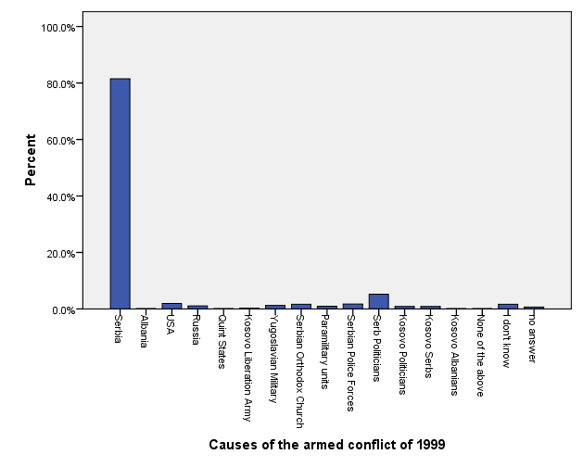
Fig. 1: Causes of the armed conflict of 1999

The second most relevant result was the response rate that blamed Serbian politicians for the armed conflict of 1999 (5.2 % of total respondent), an answer that also differed across ethnicities (5.3 % of Albanian population, 3.8% of the Serbian population, and 14.3% of the Gorani population) (CRDP Database, Table 16). Another interesting finding was that 1.9 % of the total population considered the US as the source of the armed conflict of 1999; 53.8 of the Serb population responded this way (CRDP Database, Table 17).
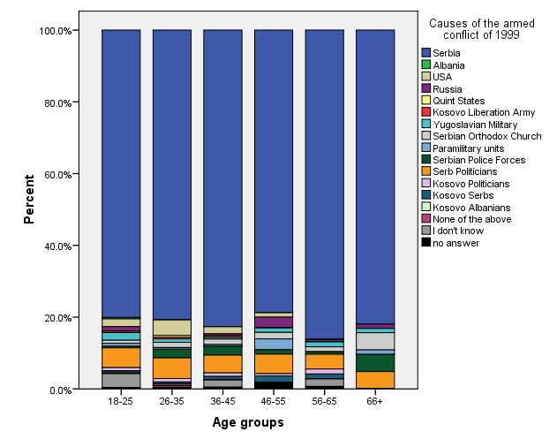
Different views on the source of the armed conflict of 1999 were not only noticed between ethnicities, but also age groups within ethnicities. Differences of opinion between ethnic groups were found to be more significant within the age range of 18 to 65 than ages above 65. There were relatively greater differences among age groups within the Serb community than the rest of ethnic groups, regarding the source of the armed conflict of 1999. Older generations tended to blame Serbian politicians and the US more often, while the younger generations blamed the Kosovo Liberation Army (KLA), the US, and Quint states more (CRDP Database, Table 18).
Fig. 2: Perceived causes of the armed conflict, by age groups
In general, the main sources of information about the conflict were reported to be parents and family, personal experience, and media (CRDP Database, Table 19). Also, the given sources of information were found to be significantly blaming different factors as causes of the respective conflict, although in general terms, the three sources mentioned earlier “preach” relatively the same story. For illustrative purposes, around 20% of people who were informed about the respective conflict by politicians put the blame on Serbs of Kosovo, whereas in the case of other sources of information, that portion did not exceed more than 3.6% (friends and neighbors) nor 0.7% (personal experience) (CRDP Database, Table 20).
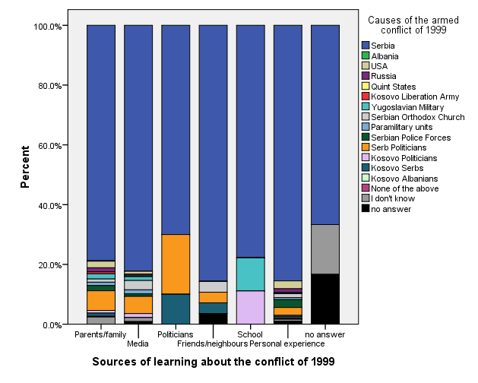
Fig. 3: Causes of the armed conflict of 1999, according to information source

As far as the actual terms of reconciliation are concerned, there is a significant difference on the level of familiarity with it among respective ethnic groups. While almost every Serb, Egyptian, and Albanian respondent claimed to have heard about it, a relatively large percentage of Ashkali, Turkish, Roma, Bosnian, and Goran respondents stated that they had never heard about reconciliation before (CRDP Database, Table 1). On the other hand, different understandings of reconciliation, when analyzed across age groups, were not significant (CRDP Database, Table 2).
The media was found to be the main source of information as far as familiarity with the concept of reconciliation, followed by schools, families, and politicians (CRDP Database, Table 3). The actual definition of the term reconciliation was found to be dependent on the type of source of information about reconciliation. Nonetheless the predominant definition of reconciliation made by those who were informed about it through the abovementioned sources is that it is a phenomenon between parents and their children (CRDP Database, Table 4).
Although these results contradict each other, once we controlled for ethnic background of our respondents, we found that such differences are applicable to Albanians and Serbs which represent the near absolute composition of our sample (targeted population). Certainly, there were significant differences. In the case of Albanians, the most common definition of reconciliation claimed by the media, schools, families, and politicians was an internal issue between parents and their children, whereas in the case of Serbs, media was equally as likely to define reconciliation as either an issue between Kosovo and Serbia or Albanians and Serbs, and schools which equally defined it as an issue between parents and their children and Serbs and Albanians. Moreover, Serbian families were found to have defined reconciliation as an internal and individual issue, whereas politicians mainly defined it as something between Kosovo and Serbia as well as Serbians and Albanians (CRDP Database, Table 5). Further, the respective inter-dependencies (relationship) described above, between the definitions of the term reconciliation with sources of information (learning) about it were found to be applicable only for those belonging to the age categories of 25 to 55 (who could be categorized as the ones who had experienced the conflict) (CRDP Database, Table 6).
Significant differences were identified with regard to what various ethnic groups consider to be the main barriers to the process of reconciliation. In the case of Albanians, the main factors were found to be Serb politicians, along with the lack of apology, truth, and justice, whereas Kosovar politicians, the international community, and lack of truth were reported as the top barriers for Serbs. Other ethnic groups considered Serbian politicians to be the main factor, followed by the lack of truth and justice (in the case of Gorani, especially) (CRDP Database, Table 7).
Moreover, those perceptions were found to be significant regardless of the source from which our respondents claimed to have learnt about the conflict of 1999, except in the case of Albanians (CRDP Database, Table 8). For Albanians, parents and families were found to be the main source of learning about the conflict in the case of all defined barriers of the reconciliation process.
Similarly, parents and families were found to be the main source of learning about the conflict of 1999 for Serbs, but the majority defined Kosovar politicians to be the greatest barrier of the process of reconciliation. The majority of Serbs who blamed the international community for being the greatest barrier to ethnic reconciliation reported learning about the event from personal experience and those who blamed absence of an apology reported learning about the event from the media (CRDP Database, Table 9).
The question regarding the current relationships between Albanians and Serbs also demonstrated significant differences among respondents of different ethnic backgrounds. In relative terms, most of Albanians consider those relationships not to be good, whereas most of Serbs categorized them as good to a certain extent. Members of other ethnic groups seem to be relatively more strongly oriented to the positive extreme, with Ashkali community leading that trend (CRDP Database, Table 10). Those perceptions were found to prevail regardless of the age (CRDP Database, Table 11) and education level (CRDP Database, Table 12).
In contrast, we found that people of different religious beliefs hold significantly different perceptions over the current relationships between Albanians and Serbs; the majority of Islam and Orthodox believers described ethnic relationships between Albanians and Serbs as not good, whereas Agnostics and Atheists predominantly oriented toward the definition of not good at all about the respective relationship (CRDP Database, Table 13). By the same token, respondents of different employment and social status were found to hold significantly different views regarding the current relationships between Albanians and Serbs, too. From the test results, it can be inferred that employed people generally have a better view on the respective relationships, with those employed in the private sector leading the way, followed by civil servants; simultaneously, respondents who were either unemployed or employed as house-keepers perceived the relationships as worse (CRDP Database, Table 14).
We also found that the perceptions over the current relationships between Albanians and Serbs differ among those who live in close proximity to the population they consider to have caused damage to. People who hold better perceptions about those relationships tended to live closer to the population that had harmed them during the conflict of 1999; such relations prevailed regardless of the ethnic background. This breaks down when age is considered. Relatively more people of the age between 18-25 and those above 56 and living in close proximity to the perceived aggressor population described the relationships between Albanians and Serbs to be not good or not good at all compared to other age groups (CRDP Database, Table 15).
Around 58.4% of the total number of respondents defined themselves as victims of the 1999 armed conflict (CRDP Database, Table 21). Although the respondents claimed to be victims of different factors, primarily ethnic discrimination, having a family member killed, or being expelled (CRDP Database, Table 22), they had stated no significant difference regarding the most important mechanism for reconciliation (CRDP Database, Table 23).
As such, the apology from the state of Serbia, financial compensation, and truth about crimes in the past were stated as the three most important mechanisms in that respect (CRDP Database, Table 24).
This was not found to be the case among people of different ethnic backgrounds; indeed, besides apology from the state of Serbia, Serbs mentioned the apology from the state of Kosovo and truth about the crimes in the past as the main means for reconciliation to happen. While other ethnic communities stated that the apology from the state of Serbia as the main mechanism of reconciliation, an exceptional case was that of the Roma, who in absolute terms declared the individual apology to be so (CRDP Database, Table 25).

Institutional effectiveness of tackling inter-ethnic issues
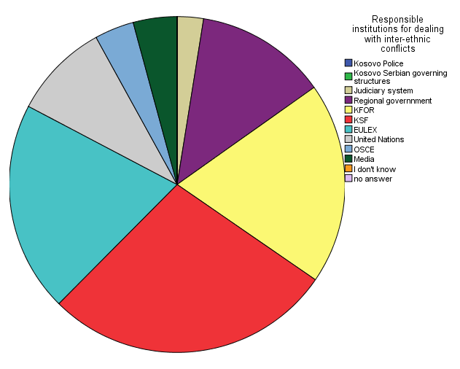
Fig. 4: Responsible authorities to deal with interethnic issues
The institution that Kosovars trust the most to solve potential interethnic conflicts is the Police of Kosovo, followed by the Judiciary system and KFOR (CRDP Database, Table 26). Those perceptions were found to be prevailing regardless of the ethnicity (CRDP Database, Table 27), age (CRDP Database, Table 28), area of living (rural vs urban) (CRDP Database, Table 29), gender (CRDP Database, Table 30), and level of education (CRDP Database, Table 31).
Simultaneously though, we found that there is no difference with regard to the perceptions of our respondents, regardless of their ethnic background (CRDP Database, Table 33), over the level of effectiveness of a particular institution to deal with potential inter-ethic issues (CRDP Database, Table 32).

Existing level of inter-ethnic interaction

The interethnic interaction in Kosovo has shown to be low. Around 52% of our respondents stated that they had never interacted with members of other ethnic groups, whereas around 19% and 6.4% declared to have interacted sometimes and most of the time, respectively (CRDP Database, Table 39).
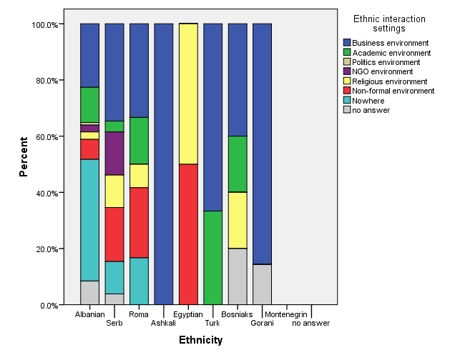
Even so, these results were found to vary significantly among different ethnic groups; while the majority of Albanians declared to have never cooperated with individuals of other ethnic groups, the rest of ethnic communities, led by Bosnians, and followed by Goran, Ashkali, Turks, Serbs and Egyptian, were found to be relatively more engaged into inter-ethnic cooperation (CRDP Database, Table 40).
Fig. 5: Preferred environment for interethnic interaction, by ethnicity

Moreover, we found that the interethnic interaction is uneasy. Specifically, more than 42% of our respondents declared that they do not feel comfortable when interacting with other ethnic groups, whereas around 26% feel rather comfortable and around 28% feel neutral (CRDP Database, Table 34). The level of ease at which interethnic interaction evolves was found to be varying depending on the context; the friendliest environment for interethnic interaction was found to be the business, education, and non-formal environment, whereas politics, religion, and non-government as the least one (CRDP Database, Table 35). Such perceptions were found to prevail regardless of ethnic background, except in the case of Albanians, who were found to be relatively more comfortable cooperating in a business and educational context (CRDP Database, Table 36).
Perceptions of interethnic interaction do differ with regard to gender and age; indeed, a relatively higher proportion of women feel more comfortable engaging in interethnic cooperation in education and non-governmental environments than men, with the latter reporting greater comfort with the business sector (CRDP Database, Table 37).
Furthermore, the relatively younger respondents declared to feel relatively more comfortable in cooperating with members of other ethnic communities in the education sector, whereas older generations prefer business and non-formal venues (CRDP Database, Table 38).
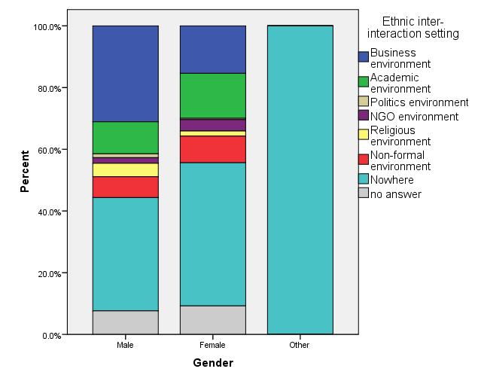
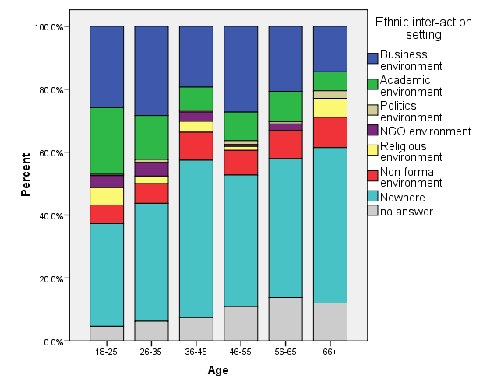
Fig. 6: Preferred environments for interethnic interaction, by gender and age
We sought to explore personal levels of interethnic interaction by asking our respondents about their opinion towards a friend or family relative marrying someone of a different ethnic background (CRDP Database, Table 42). We found that those opinions vary significantly depending on the ethnic background of the person the friend/family relative married and belonged to himself/herself. While 25% and 20.8% of Albanians would approve or absolutely approve of their friends or family relatives marrying a Serbian (CRDP Database, Table 42), the latter were found relatively more open in this sense if when the reverse context was analyzed (around 30.8% and 26.9% would absolutely approve or approve their friends or family relatives’ marriage with someone of Albanian ethnicity). Furthermore, while Ashkali, Egyptians, Roma, Goran, Bosnian, and Turks, would predominantly completely agree or agree with their friends or relatives marrying an Albanian, none of Ashkali and Turks would fully support their friend or relative marrying a Serb. A relatively small proportion of Bosnians and Goran declared the same (CRDP Database, Tables 42 and 43).

Prospects of another armed conflict
Fig. 7: Current perceptions of interethnic tensions between Kosovo Albanians and Serbs, compared to 10 years ago
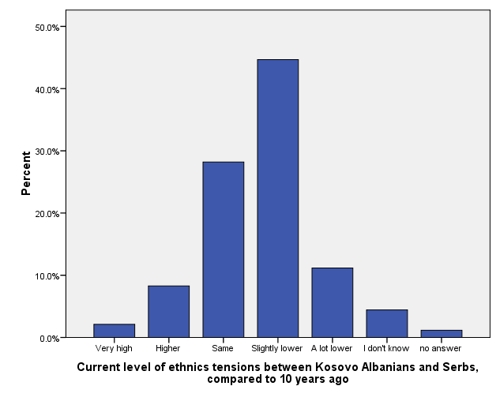
According to the results we found, it could be said that there is a relatively improving trend of the interethnic relationship. However, our respondents also fear that there is a relatively significant potential for another armed conflict to evolve.
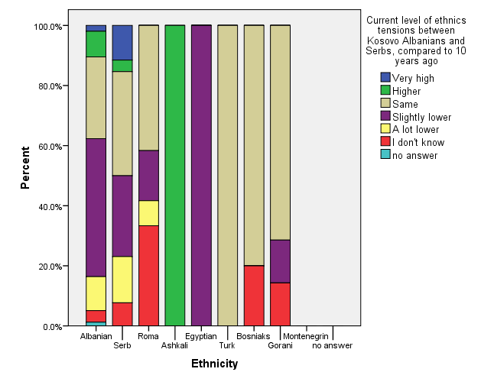
Undeniably, the majority of our respondents described the current level of tensions between Albanians and Serbs relative to that of ten years ago as relatively lower; the other most frequent opinion was found to be that such tensions are at relatively the same level as they were ten years ago (CRDP Database, Table 44).
Fig. 8: Perceptions of interethnic tensions, by ethnicity

In this regard, there were no significant differences of opinion between age groups (CRDP Database, Table 46), nor between respondents living in rural areas and those living in urban areas (CRDP Database, Table 47). Nonetheless, we found significant differences among different ethnic communities; the most distinguishing difference appears where 11% of Serbs describe tensions as a lot higher relative to ten years ago, whereas only 1.9% of Albanians described them as such (CRDP Database, Table 45).

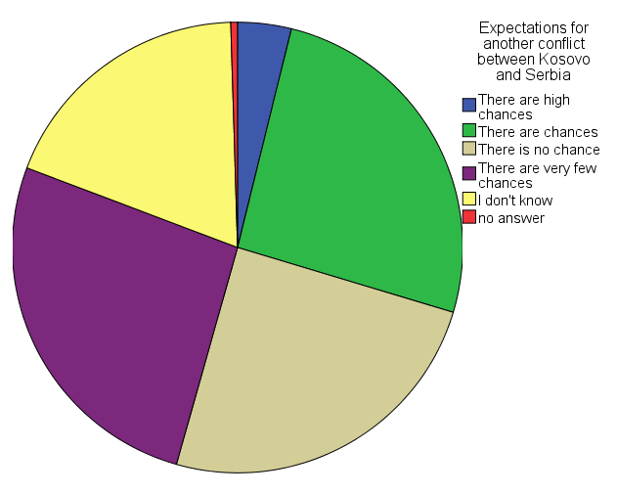
As far as expectations for another conflict are concerned, the majority of our respondents stated they believe there is no or very low chance for another conflict.
Fig. 9: Prospects of another armed conflict
Around 30% of our respondents stated they believe there is at least some chance for a conflict to occur (CRDP Database, Table 48). Simultaneously, we did not find any significant difference of opinion on if a conflict would happen among the respective ethnic groups (CRDP Database, Table 49).
The greatest differences in opinion appear across age groups. The majority of those who declared that there are high chances for another armed conflict were aged 66 or older. We found relatively younger ages to be oriented relatively more toward the two extremes. In other words, a higher proportion within each age group who expect or do not expect another armed conflict to happen belong to relatively younger age groups (CRDP Database, Table 50).
Additionally, we found a general reluctance to participate in another armed conflict; 32.5% of our respondents stated that they would be willing to fight if such a conflict were it to evolve (CRDP Database, Table 51). Overall these results were not found to significantly fluctuate among different age groups (CRDP Database, Table 53) or levels of income (CRDP Database, Table 54). However, willingness to participate varied based on the respondent’s ethnic group, areas of living, level of education and whether they felt as victims or not of the armed conflict of 1999. Albanians, followed by Roma respondents, were found to have the highest willingness to participate in another armed conflict, whereas none of the other ethnic groups, except for a relatively small portion of Serb ones (3.8%), stated to be willing to do so (CRDP Database, Table 52). Similarly, a higher willingness to participate if an armed conflict were to erupt was found among those who live in rural areas (CRDP Database, Table 55), are relatively less educated (CRDP Database, Table 56), and those who define themselves as victims of the 1999 conflict (CRDP Database, Table 57).
Lastly we found that there is a significant positive relationship between the level of expectations for another conflict and that of willingness to participate in it, had such event actually occurred, regardless of the age group (save for those above age 66) (CRDP Database, Table 58), ethnic background (except for other minorities) (CRDP Database, Table 59), and employment and social status (except if one is employed in the public of private sector) (CRDP Database, Table 60).

Qualitative research results

The concept of reconciliation

The concept of reconciliation was well known to focus group participants. Respondents face the issue of reconciliation on a daily basis, whether in their personal life or when they hear it being used in media by institutions and different organizations. The analysis of the findings of the eight focus groups enables us to identify four main discourses about the conceptualization of the construct of reconciliation. The first discourse explains the concept of reconciliation affecting the issue of compromise between the two parties that have been in conflict but who must return to the life that they had before the conflict erupted, thus sacrificing the past for a better future. This kind of compromise was described at both the individual and collective levels as a “process”. The compromise gives meaning to the reconciliation process and is particularly important because it aims to open dialogue between the parties that have been in conflict until recently.
Kosovo Serb respondents see reconciliation as something more feasible at the individual level but more difficult at the collective level, because, at the collective level, political legitimacy is required, and politicians are seen more as constraints than solutions to the reconciliation process. A considerable number of respondents from both Albanian and Serbian communities also believe that reconciliation at the individual level is more honest than that in a community level. Here we again underline the role of the state, lack of trust in its institutions, and the skepticism that respondents of all ethnicities have towards the politicians who lack political will for genuine reconciliation.
When we speak of the masses, then reconciliation is difficult because it is not a truthful process. At the individual level, reconciliation could be achieved, but at the collective level, it is unlikely. (Serbian student, Gracanica)
Ending a conflict between the two parties (whether on an individual or collective level) is often used as a metaphor by the respondents as the process of reconciliation, though a long and continuous process must at some point reach its end. This is also clear from the findings suggesting that respondents in focus groups explicitly point out that the role of different actors in the field of memory work will help historical dialogue and the reconciliation process.
I think that conflicts are the disagreements between two or more parties and which should get closer to each other and reconcile. Obviously the guilty one must apologize and a compromise must be found between them. It is not the first time that there is a conflict with Serbia, it has been for centuries and has continued further, they have always been the initiators. It is time for them (the Serbs) to understand that it cannot go on like this any longer, but they have to sit down and talk to us as equal partners, not acting superior towards us, and interfere in our internal affairs, while not touching upon theirs. This is also a major mistake of Serbia and of the Serbian people, we must talk as equals, bring issues openly to the table, both mistakes and successes, and about their mistakes towards us in the past, they should apologies and agree to live together, and not permanently inflicting conflicts (Albanian retiree, Prishtina)
Another discourse which piqued our curiosity while analyzing the outcomes of focus groups is the inevitable link between reconciliation and the ethnic dimension, especially the Albanian and Serbian one. The ethnic character of reconciliation is particularly important because it contains in itself the general component of conflicts in the Balkans. In fact, several Albanian and Serbian respondents of different ages believe that the Balkan region has always been a source of many conflicts for centuries, and that Serbian-Albanian relations must be seen in this context, yet, for the majority of Albanian respondents the concept of reconciliation was directly related to an apology offered by the wrongdoers, in this case the Serbs.
In addition to the ethnic discourse, the socio-political and economic dimensions of reconciliation were touched upon, although less frequently than the ethnic dimension. As expected, respondents, especially the elderly (retired or former pedagogues) of all ethnic backgrounds, saw reconciliation as a more successful process if done while building economic relations. Moreover, they were more tolerant of leaving the past behind for a better future of younger generations.
In fact, I believe that regarding reconciliation things have to be divided in two areas, the political and the economic... creating jobs through an open market economy and developing business could lead us towards reconciliation (Serbian Retiree, North Mitrovica)
During the focus groups discussion, the word reconciliation reflected dialogue, renewal of a broken relation, apologizing, forgiveness, or sacrifice for a better future to most respondents of all the ethnic groups. This applies also to Serb respondents for whom the word "pomirenje" in Serbian is associated with positivity, peace, calmness, and silence. On the other hand, the terms “reconciliation” or “apology” in English sounded irritating and aroused disgust.
Reconciliation in Serbian associates peace, calmness, silence, everything is beautiful, everything is calm… but when I hear the same word in English - reconciliation, associates fanaticism, something false and deceiving, an artificial term, betrayal, etc. (Serbian NGO activist, Gracanica)
This can be explained by the great presence of the international community in Kosovo, whose permanent focus on creating a multi-ethnic society has led to the devaluation of the meaning and purpose of the word “reconciliation”. Internationals have always advocated for the reconciling opposing positions and the creation of an essential dialogue between communities, especially Albanian and Serbian through activities aimed at reconciliation. Such activities entail sports, art, culture, youth dialogue and sometimes reach the political level. However, for some individuals especially those from civil society who were engaged in such activities the word is seen to have negative effects. Moreover, such activities for seventeen years after the conflict have led to the loss of trust in this attempt, as it has in practice shown to be a very long and difficult process without tangible results. To a significant number of respondents regardless of ethnicity, gender or age, there is an opinion that the concept of reconciliation is imposed on the region by the Western powers, whose components are not successfully embedded in our societies in the Balkans.
Reconciliation is when two parties after the bad thing that has happened between them, decide to continue to communicate and cooperate by reaching a reconciliation among them. In order for this to become a functional reconciliation, it should come from above (from the top of a country’s organization) which has not happened and is not even close to happen, although politicians discuss for years. This conversation is resulting with one side winning, while reconciliation involves two equal parties in dialogue, otherwise it will not be reconciliation (Albanian NGO activist, Prishtina).
We would not be able to forgive them what they did to these women. But we have to reconcile, not to forgive, we have to reconcile because they are here, they lived here, their houses are here…because when one is feeling good, everyone reconciles. But when you think they did that evil to you, you cannot forgive but we have to reconcile because we have to coexist here, and the foreigners told us that this is how we should act in order to establish a democratic country… we have to think further for our children. For their future. (Albanian war survivor, Gjakove).
A much more reasonable voice came from people who were directly affected by the war, either as family members of the victims and the missing persons or as survivors themselves. Some of them saw reconciliation as a continuous and necessary process in order to move forward, while emphasizing that finding the truth for their beloved ones who are still missing is a precondition for coexistence and reconciliation, but also the right of everyone to live where he/she was born. But forgiveness for the perpetrators was not accepted among Albanian war survival respondents.
Serb respondents insisted that apology should be an individual act and not a collective one.
Apology is something very individual… and each should review one’s own self where are their wrongs (Media Serbian, Gracanica)
The first set of questions also sought to address whether reconciliation can be achieved between communities by self-initiative or whether mediation from the international community or institutions is required. Several respondents see mediation as inevitable because of the deep feelings of ethnic mistrust, especially among Albanians and Serbs in Kosovo. Despite the lack of political balance and disputes between the two parties, Kosovo and Serbia dialogue should continue respondents insists.
However, there were also those pessimistic respondents in both sides who did not see the international community as a constructive and fruitful contributor to the reconciliation process in Kosovo.
Only if we as two nations sit and talk, meaning that the idea comes from us and not from the top, I believe it will lead to a genuine reconciliation or some kind of solution. It only needs to be a sincere willingness, coming from individuals, communities... (Serbian student, Gracanica)
As noted above, many respondents of all ethnic groups saw reconciliation as a construct imposed by the West, whose components are not successfully involved in Kosovo’s society. Some interviewees, especially civil society organizations’ members of many ethnicities, did not believe that the approach to reconciliation in Kosovo is an organic bottom-up process. Instead of being initiated by governments or societies and originating naturally from the relevant social context, it is imposed by the international community (including the European Union, who uses it as a condition for access to the EU).
It is very true that the international community has to take the flag for the reconciliation of the two peoples ... the dialogue does not make sense since the beginning. It would be meaningful, when Europe recognizes us as a state and puts us in dialogue as equal. ... I think this form of dialogue should be stopped until we are seen as equal party, accepted by the EU and Serbia. There are 5 EU countries that have not recognized us…this for Serbia is a monologue, until it does not recognize us, but considers us as part of it, Serbia considers that it is discussing with its citizens. (Albanian Student, Prishtina)
The various programs of NGOs want to initiate reconciliation with other parts of society hoping that through continuous and long-term work they will change the mentality of untrusted communities to achieve the real intended reconciliation... All this process that the international mechanism has created spins in the whirlwind and produces nothing but the salaries of few people working on those projects…” (Albanian citizen, Prishtina)
Some Serb respondents from civil society strongly articulated the view that the mediation of the international community, and especially the EU, did more harm than benefit to communities. Both Albanian and Serb respondents in particularly of young age thought that the other party was more privileged; meaning that the EU supports more Albanians and /or Serbs respectively. This is also because the EU itself was not transparent and the political representatives of Kosovo and Serbia in these talks conveyed anti-reconciliation messages to people, thus influenced negatively the views and attitudes of the wider population on both sides.
Serbs and Albanians would find a better agreement without the EU, since both sides believe that EU is taking sides and there is an impression that Serbs are the most privileged in Kosovo (Serbian civil society, North Mitrovica)
When asked what the preconditions needed to be met and the stages leading to the process of healing of survivors' wounds and society in general, apology was the core issue for most Albanians interviewed. It was also an important part of Serb, Bosniak, and Ashkali responses. Responses differed across demographics, age, profession, or experience of victimhood. Families of victims and missing persons, or war survivors themselves expressed more sympathy for the victims of other nationalities and were more open about the past than officials or teachers coming from areas much less affected by the war in Kosovo.
No, no, there is no chance of forgiving this, but even if it is forgiven, it is a process that has several stages, meaning Serbia's should apologize to (Kosovo) Albanian victims. First Serbs should accept what they did; secondly, they should initiate good relations with Kosovo, and maybe supporting Kosovo towards European integration, meaning they (Serbs) should exclude this denigrating politics towards Kosovo (Albanian teacher, Kamenica)
My husband is a missing person for 18 years now, 8 members of my family were killed, my husband with 3 brothers, my two sisters-in-law, two daughters of my brother-in-law, one brother in law without a hand... no forgiveness for them. Even today, after 18 years I do not know where my husband is. I have been left alone pregnant, after three months I gave birth, how can I forgive them? I had to raise 5 children along the streets, to provide schooling and to come to this day. I am the one to experience this, not the Serb. Besides, I do not even know the tomb of my husband is, just so I can remember him in anniversaries, take him flowers, or take my children to. I have three brothers-in-law buried in the graveyard, and the grave of my husband is empty. How can I forgive this? Do you know when I see the Parliament on TV ... I feel like jumping into the TV and tell Hashim Thaci and the other one, and another one, if you are right, where is my husband, you as politicians who represent Kosovo. I'm still talking, but I'm not heard... Now comes the date 27 April, where am I to go, my son asks for his dad for this anniversary... isn’t this difficult? How can I forgive this… and on top of this, not knowing where the body of your husband lays, what do you say to this? Albanian Survivor, Gjakovë)
Among the respondents of the Serbian community, the word reconciliation was understood on both individual and collective levels, as stated above. Those who were older thought that a man should find peace within himself and try to overcome the pain, while among the youth, and especially those dealing with reconciliation projects, the approach towards this discourse seemed a bit more complex and was viewed as a top-down issue. Responsibility for the past wrong doings in Kosovo, among few young Serb respondents was requested from both parties, Albanians and Serbs.
When we talk about reconciliation, I think the first step should be that when Thaci and Vucic meet in Brussels and shake hands, they should apologize to each other on behalf of the communities they represent. Vucic apologize on behalf of Serbs and Thaci on behalf of Albanians, because the fact is that there were crimes on both sides, and both Serbs and Albanians suffered. (Serbian Civil society, North Mitrovica)
The issue is that most of the Albanian respondents demanded that the Serbian government should provide an apology for the crimes committed against the Kosovo Albanians during the war in 1998-99. And this is seen more as a top-down approach.
Serb respondents on the other hand insisted that individuals should be responsible for the crimes committed regardless of their ethnicity, hence the courts must decide about it.
I would be extremely angry if one of our politicians would apologize in my name... Neither I nor my fellows from our village do not feel guilty of anything, because we have not committed any crime, offending someone, burning houses or killing someone. Those who committed crimes should go to jail and legal actions should be taken against them (Serbian Civil society, Gracanica)
The issue of financial compensation of war damages known by the term reparations was seen with deep distrust from the respondents. Some thought that they would never fully recover from the damage done to them, but that financial reparations can help acknowledge the pain they feel. At the same time reparations cause the perpetrator to assume responsibility for the past wrongdoings in order to improve relations between the two communities. However, many interviewees from the Albanian survivors' group, family members of the victims and missing persons saw financial compensation as humiliating and trivializing the impact of the war. They felt that blood could not be paid in money, and that the only healing of their wounds and restoration of their dignity and of the victims would be the verified truth judged in the court, where the perpetrator would receive the deserved punishment.
They are not returning the mortal remains, and let alone compensate something. We would not want any compensation, just judge them for what they did, to punish them… (Albanian victim family member, Peja).
Actually, if you don’t take responsibility for what you’ve done, then how do you think of going ahead with reconciliation, when you don’t get the verdict for what you’ve done, there is a possibility you will repeat it (Albanian civil servant, Prizren).
In most cases, the Albanian respondents were convinced that the injured party has the right to demand accountability from the party that caused the damage. These respondents listed several groups, including civil society, media, post-war associations, veterans, and associations of family members of victims and missing persons, as potential mediators or relevant stakeholders in the negotiation process, whose word should be heard during the negotiations.
During the focus group interview, we insisted on taking the opinions of the interviewees about the four issues; 1) finding the truth, 2) bringing justice to its place, and 3) punishing criminals. The fourth question we put forward was related to a conditioned amnesty of those who committed criminal offenses during the war. Albanian respondents almost unanimously stated the first three as preconditions for reaching reconciliation. In relation to possible amnesty for criminals in exchange for valuable information such as finding the truth about the remains of the missing family members, the most interesting results came from the relatives of the victims, the survivors or the family members of the missing persons from Gjakova. The respondents were of the opinion that, in exchange for information that would reveal the fate of their family members, they might forgive the criminal, even though the pain would be indescribable. They cited finding truth, laying their relatives to rest, and the healing of their wounds as the goal of requesting this information.
I would ask from him (perpetrator) to tell me what happened, who killed him, how was he killed and tell me where is the body of my husband. I am ready to face him, to ask and hear the answers until the end. For my husband and his brothers, too. (Albanian survivor, Gjakovë)
Maybe I would forgive. It is very difficult not to know where your husband is. If the remains would be returned, my wound would be healed to a certain degree, my pain eased. It was war, and if my husband body is returned, I would agree, since there is no other way out. It is very hard, but I want him back, whenever he is, I want him back. Since it is a condition, I would forgive him (the perpetrator) if he brings back my husband body (Albanian survivor Gjakovë)
We have to forgive… what we can do. Forgive in words, never from the heart (Albanian survivor Gjakovë)
I would do anything just to ask and know the truth as it happened and why it happened... I kept hopes when they told me they found his watch, and even today I think that something will be revealed… International community took that watch for the expertise but couldn’t succeed to discover... If I don’t find the truth while I’m alive, how can my children discover later? (Albanian survivor Gjakovë)
Even though war survivors were ready to accept this kind of ‘compromise’ for the sake of truth, however, the citizens coming from less-affected regions, such as Prishtina, Prizren or Kamenica, were not ready to forgive under any circumstances. They were firm in maximal punishment for the criminals.
I think that conditions like giving amnesty to the criminal should not be accepted, in no way. No conditions, equal dialogue yes, apology from the perpetrators yes, return of the wealth, documentation, information on the missing persons, the archives should be open and the truth should be revealed. Other way, the perpetrator is turning the victim into the culprit. (Albanian retiree, Prishtina)
Even if Serbia says: I recognize you, just give amnesty to all war criminals... I would still say: no. No, thank you... Absolutely not. (Albanian public servant, Prizren)
In terms of the first issue (truth finding), most of the respondents coming from families of missing persons wanted accountability from Serbia. For the other two issues (justice and punishing criminals), they felt that both national and international courts could have done more in this regard and bring justice to victims.
The trust is lost completely in everyone. What justice brought for 18 years for the missing persons and the victims… nothing was done. Maybe they in the future, but the trust is lost. (Albanian citizen, Prishtina)
Because of the post-war international community’s involvement in the process of dealing with the past and lack of efficiency in prosecuting war criminals, many Albanian and Serb respondents were skeptical of international justice system.
We believed in international justice and the Hague Tribunal, we cooperated with them and sent our people who did nothing… what is happening now? Do they want to find Albanians guilt by all means?... In Kosovo, we lost trust in internationals, as the UNMIK and EULEX systems have failed…” (Albanian public servant, Prizren)
Serb respondents were mainly focused on justice, despite their lack of trust in the judiciary’s efficiency and impartiality. Finding criminals and bringing them to justice, according to the majority Serb respondents, would lead to justice and dealing with the past. Symbolic apologies, like that of President Thaçi in July of 2016 for the Serbian victims in Kosovo, did not have a lot of value, especially not to the family of the dead and the missing.
Apologizes from the Albanians are ironic. Serbs are not satisfied by such apologize. President Thaçi’s apology for the Serbian victims was not taken seriously from the families of Serb victims. We take seriously the verdicts from the courts. (Serbian media, Gracanica)
The last two questions concerned the religious authorities and the implementation of traditional law in the Albanian community and its implementation in resolving both family and community disputes. Regarding religion and the question of whether there is any other non-political authority that could bring closer the views and attitudes of Albanian and Serbian communities in Kosovo towards reconciliation, and the role of religious leaders, respondents of all ethnic groups were of similar opinions. Respondents of all ethnicities show respect religions and its leaders, yet they would prefer the state institutions make political decisions as they have the legitimacy to do so.
Now it has become a fear to even mention the Imams, when you don’t know what kind of Imam he is… when there is no state and justice, what can the Imam do? (Albanian survivor, Gjakova)
Despite the fact that majority of Albanian and Serb respondents did not deny the power and positive influence of some religious leaders of all religions to the wider population, they did not in any way think that clerics have the power to reconcile communities, especially not about the bitter past. There were also respondents who thought that the preaching of the clergymen should be heard with reservation because often the masses fall to their manipulations such as hate and anti-gay speech, inciting hatred etc.
I would not accept anything just because the Imam says so, how can I accept to reconcile with the Serbs, since everyone has their own wounds and it’s not that easy to accept. (Albanian public servant, Prizren)
I think that reconciliations and truth are achieved when we reconcile with ourselves. When we elect trustworthy people, when we develop ourselves, then we can reconcile with others, too. We are a secular state, and in state’s absence, weak institutions, then the Muslim and Orthodox clerics comes to surface. So, we have to work in many segments of life in Kosovo in order first to trust in ourselves, then reconcile with the others (Albanian Teacher, Kamenica).
In the absence of a fair and free legal system, the Albanian community largely regards clerics and customary law or “elderly mediators” as alternative mechanisms of bringing justice between two disputed sides. Regardless of which region of Kosovo they came from, and despite a certain level of skepticism, most of the Albanian respondents appreciated the readiness of elders who have credibility and authority in their community to mediate between the Albanian families. Three Albanian respondents did not exclude the possibility that a man like Anton Çeta who in 1990s helped eradicate bloody feuds in Kosovo, could be found nowadays, thus bridge the gap between Albanian and Serbian communities in particular.
I applaud anything that comes with a good will. For example, in the 90’s, Anton Çeta – a good man with lots of authority to mediate and eradicate bloody feuds… maybe other uncorrupted and people with high credibility such as a Mayor, or a Judge, a good Imam, a good priest, could results. (Albanian civil servants, Prizren)
Those who came from Dukagjini region (Western Kosovo), had better impressions of and were more open to “elderly mediators” in solving different family contests between.
I never heard that their (elderly men with high credibility) word was put into question… they are religious, and the most respected men in a village, community, region. I speak from what I have heard. For example, they reconciled contests which even a judge could not. There is this element among Albanian elderly mediators that when they give their word, it never happens that such a word would be broken. (Albanian family member of a victim, Peja).
Meanwhile, the leadership issue or the issue of an alternative authority in the Serbian context does not exist.
No one would respect the “elderly man” among us (Serbs), or another authority in the community, somehow, even if such authority exist, people would do the opposite. Only law and courts are respected, nothing else matter (Serbian Civil society, Gracanica).
Serb respondents were firmly against any other authority that would bring on justice apart from the court. They did not sympathize with the discourse of an apology as a concept, and even less if an authority such as a political leader or a Cleric apologizes on their behalf. The official dictionary such as Matica Srpska-Dictionary of the Serbian language translates the Serbian word 'izvinjenje' as apology and 'oproštaj'1 as asking for forgiveness, which is treated at an individual, spiritual, and religious level. It also uses the word “repentance”, which implies that when someone does one wrong to another and he then repents for what he has done.
I would ask for forgiveness for a mistake, but I would never apologize to anyone.
We forgive to others (praštamo drugima), but we do not apologize (nečemo da se izvinjavamo) (Serbian student, North Mitrovica).
Apology has to do with religion, the Orthodox Church does not recognize apology, but preaches forgiveness.
We have another term preached by the Church and has to do with repentance which, as a concept, touches the individual and not the community and is more spiritual. This means that when someone repents for the mistakes he/she has done; he/she expresses more the spiritual state. Or this can be analyzed from the philosophical point of view. (Serbian civil society, Gracanica).
It is human to make a mistake but also to forgive. Even the Church has turned into a corporate-like and has entered politics… but Orthodoxy as a religion is something else from what is happening today (Serbian retiree, North Mitrovica).
Although the Orthodox Church was the most trusted institution among most Serb respondents, also based on the fact that religion and the Orthodox Church were very important in their lives and their identity, when it comes to any sort of trust, the answers were very individual. For some, trust was stronger while for others there was less trust towards church authorities. They claimed: I do not believe in the Church as the institution, but I do believe in Orthodoxy.
Other topics touched upon by the respondents, which are relevant for this paper include:
The lack of knowledge about each other's cultures between Albanians and Serbs, especially among the new post-war generations, precludes useful reconciliation dialogue. The narratives offered to them by the family as well as the curricula do not serve a genuine dialogue. This has increased the prejudices between the two sides.
We live here for years but do not know each other. We do not understand how others around us live, especially the generations after the 90’s which did not have the chance to know each other. There is a misunderstanding, and if we would know each other better, maybe reconciliation would be achieved easier… the youngsters don’t even know who suffered and to what extent during the war. Neither do Albanians know about Serbs, nor do Serbs know about Albanians (Serbian activist NGO Gracanica)
Lack of contacts between Serb and Albanian youngsters is evident and this creates huge divisions. Interpretation of two histories of the two communities is different. That’s why we should begin at the individual and an informal level to communicate, maybe through sports and cultural events… while confronting the victims should be the final phase since those encounters are more difficult (Serbian student, North Mitrovica).
The existing narratives of the past are marked by unreliable information and heavy politicization, meaning they are contentious and do not lead to reconciliation. On the contrary, they create gaps of communication and increase mistrust, especially among young people.
If Albanians claim that there are still 1,200 missing Albanians and 400 Serbs, our data give us the total number of 1,300 missing Serbs, and when we cannot agree on this point, how can we continue to communicate in other topics? 40,000 Serbs do not live in Prishtina anymore, should someone apologize to us for this? (Serbian civil society, Gracanica)
Politics is seen as an obstacle and not a solution by both sides.
The people still do not trust in politicians’ rhetoric, and the messages sent by politicians are important. If they had a more reconciling tone, it would have an impact to the wider public (Serbian civil society, North Mitrovica)
It was clear that most of the respondents from all communities were skeptical about the official politics and suspicious about the motives of the politicians. Some insisted that at the individual level, however, Serbs and Albanians would reconcile, but the official politics deepen the already large gap between the two communities and decelerate negotiations. The respondents in their discussions separated the political sphere from their daily lives and this shows clearly that the citizens still do not have ownership of the ongoing political processes, a clear indicator that democracy is still not well consolidated in Kosovo.

Qualitative Main Findings
- Respondents saw reconciliation as an organic process and as more achievable through a bottom-up approach (emerging as a need of the citizens for a better life), rather than a top-down imposed process (from both governments and the international community).
- Respondents directly or indirectly linked the term of reconciliation with tensions and ethnic conflicts beyond just those of recent war in Kosovo, and this term was automatically transcended from the individual to the collective level. Kosovo institutions should work harder about the continuous collective memory.
- There is a great discrepancy between generations over the issue of reconciliation and coexistence. The young respondents, both Albanians and Serbs in their late twenties and who did not experience the war lacked knowledge of each other and their narratives are diametrically opposite. The Serb respondents and some Albanians of up to 40s are very skeptical of the future and the international community involvement, while retirees, both Albanians and Serbs, were more positive and optimistic about reconciliation and a common future.
- Majority of Albanian and Serb respondents tend to believe that reconciliation can be done more easily through economic development, through creation of job opportunities and improving of living standards.
- Reconciliation as a process from the Albanian side was directly linked to the Serbian Government's apology for the damages of the recent war, while it raised disgust among Serb respondents who considered seeking forgiveness as an individual and non-collective act. Moreover, Serbs did not recognize any authority that could ask for forgiveness in their name.
- This research also showed that those directly affected by the war (survivors, family of victims and missing persons) were more oriented toward finding truth and living in peace, while those coming from areas less affected by war and who had no victims in their families were less favorable of reconciliation and saw it more as a pressure from above than the need of the citizens. Meanwhile, the latter category (less affected) considered that the party that caused the damage (in this case the Serbs) must be held responsible for the human and economic losses.
- Respondents see the role of the international community as a mediator as a necessity, however, though not desirable. Both Albanian and Serb respondents coming from civil society considered reconciliation an artificial process and lacked trust in mediators like the EU. Retired persons and older respondents were categorical that mediation was necessary.
- Trust in decision-makers and government is very low, and they are more seen as obstacles and inciters of conflicts rather than mediators or guarantors of peace and reconciliation.
- Majority of respondents of all ethnic groups showed little trust on local judiciary, but they also criticized the international courts for not bringing justice to victims of war.
- The international community should understand reconciliation support more broadly, going beyond supporting the civil society organizations’ cultural and social inclusion activates. Linkages need to be made between the formal initiatives on transitional justice initiated by the Kosovo government, civil society organizations’ activities and taking into consideration cultural specifics.
- Most respondents viewed the Islamic Community, Catholic, and Orthodox Churches with a dose of skepticism. According to them regardless of ethnic background, religion at its core is peaceful but the clergy isn't necessarily.
- Albanian respondents saw the implementation of the Code of Lekë Dukagjini as a norm that replaces the lack of rule of law, but not as a necessity for resolving private or family disputes, and absolutely not disputes between communities of different ethnicities.
- Reconciliation requires more than peaceful coexistence, which is insufficient for building good relations necessary to prevent long disputes. Yet, reconciliation does not necessarily necessitate the establishment of forgiveness, a process that according to most Serb respondents was rejected as such and its achievability is questionable.

CONCLUSION
Achieving reconciliation and sustainable peace in Kosovo are important components of state building. Kosovo is a country that to this day carries the weight of the bitter history of bad relations between Albanians and Serbs. This drives especially these two communities to work harder and find feasible ways to coexist.
Our main aim in this study was to address the almost total lack of research evidence on the meaning of reconciliation within the wider population in Kosovo. We have done so by doing both quantitative and qualitative research with special attention to include the most vulnerable segments of society, survivors of war, and members of families of victims and missing persons. We believe that our research is especially timely in the aftermath of the series of formal and non-formal initiatives that have taken place in Kosovo in the field of transitional justice. Hereafter, a major practical contribution of this research is that it provides much needed empirical data on the actual situation in transitional justice and will enable us to reframe the process of dealing with the past in Kosovo and how to nurture it and support further.
A second important implication of this study derives from the findings on the uniqueness of the knowledge and information work carried out. Thirdly, we looked at framing the options and how to move forward.
Although the authorities have been engaged in promoting reconciliation and integrating minorities, especially the Serb minority in Kosovo, and have produced a considerable number of official documents as a frame for a better minority integration, there is a huge gap between the respective legislation on one side and its implementation in practice on the other.
There is no doubt that the reconciliation process cannot be defined in a unilateral manner and that it is necessary to have different viewpoints. Likewise, Kosovar citizens (our respondents) see the process of reconciliation as a continuation of economic development first and of political stability rather than as a top down process supported by the international community and dishonestly so far promoted by politicians.
As far as the meaning of reconciliation is concerned, there is a significant difference on the level of familiarity with it among respective ethnic groups. An important consideration when speaking of reconciliation in the context of Kosovo is that the term has strong individual and ethnic connotations. Nonetheless, the predominant definition of reconciliation among all ethnic groups’ respondents is that it is a phenomenon between parents and their children.
Even though the young generation is seen as the group that should be the bearer of change and a catalyst of reconciliation in the future, the young respondents of both ethnicities demonstrated skepticism for a common future. Albanian respondents highlighted that the main barriers to the process of reconciliation among other barriers is lack of cooperation with individuals with other ethnic groups. However, it was not the same for the rest of ethnic communities, led by Bosnians, Gorani, Ashkali, Turks, Serbs and Egyptian, who seems to be relatively more engaged into inter-ethnic cooperation. Parents and families were found to be the main source of learning about the latest conflict.
On the other hand, an economic and development aspect in this dimension provides more hope for the reconciliation process. The level of ease at which interethnic cooperation evolves was found to be varying depending on the context; the friendliest environments for inter-ethnic cooperation were found to be business, education, and non-formal environments, whereas political, religion, and non-government sector were the least friendly. The most interesting finding from these responses was the view of those employed citizens who generally have a better view on the respective relationships between Albanians and Serbs, compared to unemployed respondents who perceived the relationships between the two as worse.
The issue of apology and reconciliation was by far the most controversial topic of the focus group discussions. This was not found to be the case among people of different ethnic backgrounds; indeed, besides an apology from the state of Serbia as asked by Albanians, Serbs also mentioned the apology from the state of Kosovo and truth about the crimes in the past as the main means for reconciliation to happen. Responses differed across the demographics of age, profession, or experience of respondents. The great majority of the Albanian respondents however, transferred the responsibility for the conflict on the Serbian side. In line with that were mentioned also the lack of apology, truth, and justice.
Families of victims and missing persons or war survivors themselves expressed more sympathy for the victims of other nationalities and were more open about the past than officials or teachers coming from areas much less affected by the war in Kosovo.
The interviewees regarded all religious leaders with a great deal of criticism and skepticism. While the respondents did not deny the peaceful mission and role of religious communities, individual clergy and specific religions were viewed with a critical eye and not well regarded by a considerable number of the respondents. Religion plays a certain role in all communities in Kosovo. Yet, an interesting response came from both Islam and Orthodox believers who tended to be lightly optimistic about ethnic relationships between Albanians and Serbs claiming that they aren’t good enough, compared with the Agnostics and Atheists who firmly believe that ethnic relations are not good at all.
In a more optimistic note and according to the results we found, it could be said that the interethnic relationship is trending towards improvement. However, our respondents also fear that there is a relatively significant potential for another armed conflict to evolve.
Based on the responses, it is clear that citizens regardless of ethnic background see their role in the reconciliation process as submissive compared to the decision makers. In the majority of the responses, especially among Albanian respondents, the discourse of the victim, helplessness, and fatalism prevailed. Respondents were generally very articulate when it came to the role of education of the young generations in the reconciliation process.
One of the approaches in reaching about reconciliation in the future needs to be locally based, thus traditional national/macro level narratives about victimhood/ownership need to be abandoned, and instead the citizens of Kosovo, regardless of ethnicity, should focus on micro-level/individual relationships in order to make a lasting change.
Support for transitional justice, including by the UN and the EU, should be more context specific, aiming to create partnerships in highly political sensitive contexts in Kosovo.
A large number of Serb, and some Albanian, respondents were critical towards further involvement of the international donor community in reconciliation processes, and respondents of all ethnic groups negatively evaluated the works of both the national and international justice system. Therefore, the international community and Kosovo Government need to urgently strengthen coordination on transitional justice on the ground and focus on bottom-up approaches.

REFERENCES

- Ahmetaj, N. & Unger, T. (2017). Kosovo’s Framework for Dealing with the Past at a Turning Point: Civil society review of progress toward a National Strategy on Transitional Justice. Retrieved from: https://www.paxforpeace.nl/publications/all-publications/kosovos-framework-for-dealing-with-the-past-at-a-turning-point
- Andrieu, K. (2012), La justice Transitionnelle. Folio Essai Inédit. Paris, France: Gallimard.
- Application of the Convention on the Prevention and Punishment of the Crime of Genocide (Bosnia and Herzegovina v. Serbia and Montenegro). (2007, February 26). Retrieved from: http://www.icj-cij.org/docket/index.php?pr=1897&code=bhy&p1=3&p2=3&p3=6&case=91&k=f4.
- Arsovska, J. & Verduyn, P. (2008). Globalization, conduct norms and ‘culture conflict’, Perceptions of Violence and Crime in an Ethnic Albanian Context. British Journal of Criminology, Volume 48, pp. 226–246.
- Bar-Tal, D. & Bennink, G.H. (2004). The nature of reconciliation as an outcome and as a process. In Y. Bar-Siman-Tov (ed.), From conflict resolution to reconciliation. Oxford, United Kingdom: Oxford University Press (also published in Politika, 2002, Issue No 9, pp. 9-34 in Hebrew), pp. 11-38.
- Bar-Tal, D. (2008). Reconciliation as a Foundation of Culture of Peace. In Joseph de Rivera (ed.), Handbook on Building Cultures of Peace, Peace Psychology Book Series. New York, USA: Springer-Verlag New York, pp. 363-377.
- Berghof Glossary on Conflict Transformation. (2012). 20 notions for theory and practice, Berghof Foundation (ed.). Berlin, Germany: Berghof Foundation Operations GmbH.
- Bethlehem, D. L. & Weller, M. (1997). The 'Yugoslav' Crisis in International Law. Cambridge International Documents Series. Cambridge, United Kingdom: Cambridge University Press.
- Bleeker, M. & Sisson J. (eds.). (2004). Dealing with the Past: Critical Issues, Lessons Learned and Challenges for Future Swiss Policy. Working Paper 2/2004, KOFF Series. Bern, Switzerland: Swisspeace.
- Bloomfield, D., Barnes, T. & Huyse, L. (2003). Reconciliation After Violent Conflict. A Handbook. Stockholm, Sweden: International Institute for Democracy and Electoral Assistance (IDEA). Retrieved from:
http://www.idea.int/publications/catalogue/reconciliation-after-violent-conflict-handbook.
- Brounéus, K. (2003). Reconciliation – Theory and Practice for Development Cooperation. Stockholm: Swedish International Development Cooperation Agency (SIDA). Retrieved from: http://www.sida.se/English/publications/Publication_database/publications-by-year1/2003/september/reconciliation---theory-and-practice-for-development-cooperation/
- Burgess, T. F. Guide to the Design of Questionnaires. (2001). Retrieved from http://iss.leeds.ac.uk/downloads/top2.pdf.
- Central Intelligence Agency. (2017). The World Factbook page on Kosovo. Retrieved from https://www.cia.gov/library/publications/the-world-factbook/geos/kv.html.
- Clark, P. (2010). The Gacaca courts, post-genocide justice and reconciliation in Rwanda, Justice without lawyers. Cambridge, United Kingdom: Cambridge University Press.
- Comprehensive Proposal for Kosovo Status Settlement. (2007, March 26).
- Daxner, M. (2010). Hindsight is Easier than Foresight: Taking Stock of International Engagement in Kosovo. In Ernst M. Felberbauer, Predrag Jurekovic (eds), 15 Years of Peace-Building in the Western Balkans - Lessons Learnt and Current Challenges. Vienna: National Defence Academy, pp. 41-57.
- Di Lellio, A. & McCurn, C. (2012). Engineering Grassroots Transitional Justice in the Balkans: The case of Kosovo. East European Politics and Societies, 27 Number 1, pp.1-20.
- Dwyer, S. (2003). Reconciliation for Realists. In Carol A. L. Prager and Trudy Govier (eds), Dilemmas of Reconciliation: Cases and Concepts. Waterloo, Ont., Canada : Wilfrid Laurier University Press.
- Easton, V. J., & McColl, J. H. Statistics Glossary. (1997). Retrieved May 7, 2017, from http://www.stats.gla.ac.uk/steps/glossary/.
- Fisher, M. (2011). Transitional Justice and Reconciliation: Theory and Practice. In B. Austin, M. Fischer, H.J. Giessmann (eds.), Advancing Conflict Transformation. The Berghof Handbook II. Opladen/Framington Hills: Barbara Budrich Publishers. Retrieved from :
http://www.berghof-foundation.org/training/berghof-handbook-for-conflict-transformation/handbook-articles/transitional-justice-reconciliation/.
- Fischer, M. & Petrović-Ziemer, L. (eds.). (2013). Dealing with the Past in the Western Balkans. Initiatives for Peacebuilding and Transitional Justice in Bosnia-Herzegovina, Serbia and Croatia. Berghof Report No. 18. Berlin: Berghof Foundation. Retrieved from: http://www.berghof-foundation.org/fileadmin/redaktion/Publications/Papers/Reports/br18e.pdf.
- Five Senior Serb Officials Convicted of Kosovo Crimes, One Acquitted. (2009, February 26). Retrieved from: http://www.icty.org/en/press/five-senior-serb-officials-convicted-kosovo-crimes-one-acquitted
- Gallucci, G. (2011). The Ahtisaari Plan and North Kosovo, TransConflict. Retrieved from: http://www.transconflict.com/2011/11/ahtisaari-plan-north-kosovo-011/.
- Gacaca Community Justice. (n.d.). Retrieved from: http://gacaca.rw/about/history-3/
- Hourquebie, F. (2014). La justice transitionnelle a bien un sens, Afrique contemporaine, n° 250, pp. 86-87. Retrieved from: https://www.cairn.info/revue-afrique-contemporaine-2014-2-page-86.htm.
- International Criminal Tribunal for the former Yugoslavia Calls for papers for June 2017 Legacy Conference. (2016, November 01).
Retrieved from: http://www.icty.org/fr/press/tribunal-p%C3%A9nal-international-pour-l%E2%80%99ex-yougoslavie-appel-%C3%A0-contributions-pour-la-conf%C3%A9rence.
- International Recognitions Of The Republic Of Kosovo - Foreign Policy. (n.d.) Retrieved from: http://www.mfa-ks.net/?page=2%2C224
- Istrefi, R. (2016). From Peace Building to State Building: Human Rights and Transitional Justice Processes in Kosovo, June 30, 2016. European Yearbook on Human Rights, Vol. 16, p. 459-472. University of Prishtina Faculty of Law Research Paper No. 2891984.
- Judah, T. (2008). Kosovo, What everyone needs to know. New York, USA: Oxford University Press.
- Kosovo Court to be established in The Hague. (2016, January 15). Retrieved from:
https://www.government.nl/latest/news/2016/01/15/kosovo-court-to-be-established-in-the-hague.
- Kostovicova, D. (2013). Civil society and reconciliation in the Western Balkans: great expectations? In Prifti, E. (ed.), The European Future of the Western Balkans: Thessaloniki@ 10 (2003-2013). Conde-sur-Noireau, France: European Union Institute for Security Studies (EUISS), pp. 101-107.
- Kostovicova, D. (2016). Seeking justice in a divided region. Text Analysis of Regional Civil Society Deliberations in the Balkans. International Journal of Transitional Justice (IJTJ), online-first 2016.
- Lacey, M. (2014). Categorical Data. Retrieved May 14, 2017, from http://www.stat.yale.edu/Courses/1997-98/101/stat101.htm
- Law on ratification of the stabilization and association agreement between the Republic of Kosovo, of the one part, and the European Union and the European Atomic Energy Community, of the other part, Law no. 05/L-069, 2015.
- Law on the status and the rights of the martyrs, invalids, veterans, members of Kosovo Liberation Army, civilian victims of war and their families, Law No. 04/L-054, 2011.
- Lederach, J. P. (1997). Building Peace: sustainable reconciliation in divided society. Washington D.C., USA: United State institute of Peace Press.
- Lederach, J. P. (2001) Civil society and reconciliation. In C. Crocker, F.O. Hampson & P. Aall (Eds.), Turbulent peace: The challenges of managing international conflict. Washington D.C., USA: United States Institute of Peace Press, pp.841-854.
- Loveman, B. & Lira, E. (2007). Truth, Justice, Reconciliation, and Impunity as Historical themes: Chile, 1814-2006. Radical History Review, Winter 2007, pp.43-76.
- Mandates and Crimes under ICTY Jurisdiction. (n.d.). Retrieved from:
http://www.icty.org/en/about/tribunal/mandate-and-crimes-under-icty-jurisdiction
- Matica Srpska-Dictioctionnary, retrieved from: https://goo.gl/X2R2da.
- Michael, R. S. (n.d.). Crosstabulation &amp; Chi Square Chi-square as an Index of Association. Retrieved from:
http://www.indiana.edu/~educy520/sec5982/week_12/chi_sq_summary011020.pdf
- Milo, P. (2006). The conclusion of Kosovo Status – contribution for peace and stability in the Western Balkans. In Takehiro Togo and Negoslav P. Ostojic (eds), National and Inter-Ethnic Reconciliation and religious tolerance in the Western Balkans. Belgrade, Serbia: European Center for Peace and Development (ECDP) of the United Nations University for Peace, pp. 41-46.
- Minow, M. (1998). Between Vengeance and Forgiveness: Facing History After Genocide and Mass. Martha Minow on forgiveness. Boston, USA: Beacon Press, p. 2.
- Morozzo della Rocca, R., Irwin, Z. T. & Bieber, F. (2015). In P. Ramet Sabrina, Simkus Albert and Listhaug Ola (ed.), Civic and Uncivic values in Kosovo, History, politics, and value transformation. Budapest, Hungary; New York, USA: Central European University Press.
- Murphy, J. G. & Minow, M. (1999). Fordham Urban Law Journal, Volume 27, Number 5. The Berkeley Electronic Press (bepress): http://ir.lawnet.fordham.edu/ul
- Murphy, G. J. (2012). Punishment and the Moral Emotions: Essays in Law, Morality, and Religion. Oxford University Press.
- Nato’s role in Kosovo. (2017, March 09). Retrieved from: http://www.nato.int/cps/en/natolive/topics_48818.htm
- Ramsbotham, O., Miall, H., & Woodhouse, T. (2011). Contemporary conflict resolution: The prevention, management and transformation of deadly conflicts. Cambridge, UK: Polity.
- Reja, U., Manfreda, K. L., Hlebec, V., & Vehovar, V. (2003). Open-ended vs. Close-ended Questions in Web Questionnaires. Developments in Applied Statistics Anuška Ferligoj and Andrej Mrvar (Editors) Metodološki Zvezki, 19. Retrieved from: https://pdfs.semanticscholar.org/5843/87c36946276b189fdd8a968e39021786a385.pdf.
- Skaar, E. (2013). Reconciliation in a Transitional Justice Perspective, Transitional Justice Review, Volume 1, Issue 1, Article 10, pp 54-103.
- Stabilisation and Association Agreement (SAA) between the European Union and Kosovo enters into force. (2016, April 01). Retrieved from: http://europa.eu/rapid/press-release_IP-16-1184_en.htm
- Subotic, J. (2013). Diverging paths in the Western Balkans. Current History, March 2013, pp.107-113.
- Subotic, J. (2015). Truth, Justice, and Reconciliation on the ground: normative divergence in the Western Balkans. Journal of International relations and development, Volume 18, Issue 3, pp. 361-382.
- Sweeney, J. & Ahmetaj, N. (2015). Post-war memorialization and dealing with the past in Kosovo. Center for Research, Documentation and Publication (CRDP). Kosovo, Pristina.
- Touquet, H. & Vermeersch, P. (2016). Changing Frames of Reconciliation: The politics of Peace-Building in the Former Yugoslavia. East European Politics and Societies and Cultures, Volume 30 Number 1, pp.55-73.
- Visoka, G. (2017). Shaping Peace in Kosovo: The Politics of Peacebuilding and Statehood. Rethinking Peace and Conflict Studies Collection. Switzerland: Springer International Publishing AG.
- Wyse, S. E. (2012). Benefits of Using Cross Tabulations in Survey Analysis. Retrieved May 14, 2017, retrieved from https://www.snapsurveys.com/blog/benefits-cross-tabulations-survey-analysis/

CRDP ‘Deconstructing Reconciliation in Kosovo’ Database.

- Table 1: 8. What is your ethnicity? * 21. Have you heard about the word reconciliation? Cross tabulation
- Table 2: 8. What is your ethnicity? * 21. Have you heard about the word reconciliation? * 2. How old are you? Cross tabulation
- Table 3: 22. From whom or where have you heard the word reconciliation?
- Table 4: 21. Have you heard about the word reconciliation? * 23. According to your opinion, between who can reconciliation be defined? Cross tabulation
- Table 5: 23. According to your opinion, between who can reconciliation be defined? * 22. From whom or where have you heard the word reconciliation? * 8. What is your ethnicity? Cross tabulation
- Table 6: According to your opinion, between who can reconciliation be defined? * 22. From whom or where have you heard the word reconciliation? * 2. How old are you? Cross tabulation
- Table 7: 30.1 What are the main obstacles that prevent you from ethnic reconciliation? * 8. What is your ethnicity? Cross tabulation
- Table 8: 27. Where have you learned or heard about the conflict in 1999? * 30. What are the main obstacles that prevent you from ethnic reconciliation? Cross tabulation
- Table 9: 27. Where have you learned or heard about the conflict in 1999? * 30. What are the main obstacles that prevent you from ethnic reconciliation? * 8. What is your ethnicity? Cross tabulation
- Table 10: 25. What do you think about relations between Serbs and Albanians in Kosovo? * 8. What is your ethnicity? Cross tabulation
- Table 11: 25. What do you think about relations between Serbs and Albanians in Kosovo? * 2. How old are you? * 8. What is your ethnicity? Cross tabulation
- Table 12: 25. What do you think about relations between Serbs and Albanians in Kosovo? * 12. Level of education: Cross tabulation
- Table 13: 11. What is your religion? * 25. What do you think about relations between Serbs and Albanians in Kosovo? Cross tabulation
- Table 14: 13. Employment and social status: * 25. What do you think about relations between Serbs and Albanians in Kosovo? Cross tabulation
- Table 15: 31. Do you live close to those that damaged you during the armed conflict in 1999 (neighbourhood or locality)? * 25. What do you think about relations between Serbs and Albanians in Kosovo? * 2. How old are you? Cross tabulation
- Table 16: 26.1Who do you think is responsible for the armed conflict in 1999?
- Table 17: 26. Who do you think is responsible for the armed conflict in 1999?
- * 8. What is your ethnicity? Cross tabulation
- Table 18: 26. Who do you think is responsible for the armed conflict in 1999? * 8. What is your ethnicity? * 2. How old are you? Cross tabulation
- Table 19: 27. Where have you learned or heard about the conflict in 1999?
- Table 20: 26.1 Who do you think is responsible for the armed conflict in 1999? * 27. Where have you learned or heard about the conflict in 1999? Cross tabulation
- Table 21: 32. Do you consider yourself a victim of the period 1989 – 1999
- Table 22: 33. If yes, a victim of what do you consider yourself/ or a member of your family?
- Table 23: 33. If yes, a victim of what do you consider yourself/ or a member of your family? * 36. What is the most important thing about reconciliation? Cross tabulation
- Table 24: 36. What is the most important thing about reconciliation?
- Table 25: 36. What is the most important thing about reconciliation? * 8. What is your ethnicity? Cross tabulation
- Table 26: 39. In the given situation: If there is a conflict between different ethnic groups, who should solve the conflict?
- Table 27: 39. In the given situation: If there is a conflict between different ethnic groups, who should solve the conflict? * 2. How old are you? Cross tabulation
- Table 28: 39. In the given situation: If there is a conflict between different ethnic groups, who should solve the conflict? * 2. How old are you? Cross tabulation
- Table 29: 39. In the given situation: If there is a conflict between different ethnic groups, who should solve the conflict? * Describe the type of locality. Cross tabulation
- Table 30: 39. In the given situation: If there is a conflict between different ethnic groups, who should solve the conflict? * 1. Gender Cross tabulation
- Table 31: 39. In the given situation: If there is a conflict between different ethnic groups, who should solve the conflict? * 12. Level of education: Cross tabulation
- Table 32: 39. In the given situation: If there is a conflict between different ethnic groups, who should solve the conflict? * 40. Based on the above response, how does the chosen actor solve the issue? Cross tabulation
- Table 33: 39. In the given situation: If there is a conflict between different ethnic groups, who should solve the conflict? * 40. Based on the above response, how does the chosen actor solve the issue? * 8. What is your ethnicity? Cross tabulation
- Table 34: 41. How comfortable do you feel in interacting with other ethnic groups?
- Table 35: 41. How comfortable do you feel in interacting with other ethnic groups? * 43. In which spaces would you feel comfortable to interact with the other ethnic group? Cross tabulation
- Table 36: 41. How comfortable do you feel in interacting with other ethnic groups? * 43. In which spaces would you feel comfortable to interact with the other ethnic group? * 8. What is your ethnicity? Cross tabulation
- Table 37: 41. How comfortable do you feel in interacting with other ethnic groups? * 43. In which spaces would you feel comfortable to interact with the other ethnic group? * 1. Gender Cross tabulation
- Table 38: 41. How comfortable do you feel in interacting with other ethnic groups?* 43. In which spaces would you feel comfortable to interact with the other ethnic group? * 2. How old are you? Cross tabulation
- Table 39: 42. Do you interact with the other ethnic group?
- Table 40: 42. Do you interact with the other ethnic group? * 8. What is your ethnicity? Cross tabulation
- Table
- Table 42: 44.1 Kosovo Albanian * 8. What is your ethnicity?
- Table 43: 44.2 Kosovo Serb * 8. What is your ethnicity? Cross tabulation
- Table 44: 45. Compared to 10 years ago, how is the ethnic tension today, between Kosovo Serbs and Albanians?
- Table 45: 45. Compared to 10 years ago, how is the ethnic tension today, between Kosovo Serbs and Albanians? * 8. What is your ethnicity? Cross tabulation
- Table 46: 45. Compared to 10 years ago, how is the ethnic tension today, between Kosovo Serbs and Albanians? * 2. How old are you? Cross tabulation
- Table 47: 45. Compared to 10 years ago, how is the ethnic tension today, between Kosovo Serbs and Albanians? * Describe the type of locality Cross tabulation
- Table 48: 46. Do you foresee a conflict between Serbia and Kosovo?
- Table 49: 46. Do you foresee a conflict between Serbia and Kosovo? * 8. What is your ethnicity? Cross tabulation
- Table 50: 46. Do you foresee a conflict between Serbia and Kosovo? * 2. How old are you? Cross tabulation
- Table 51: 47. Would you support or participate in a potential conflict between Serbia and Kosovo? Statistic
- Table 52: 47. Would you support or participate in a potential conflict between Serbia and Kosovo? * 8. What is your ethnicity? Cross tabulation
- Table 53: 47. Would you support or participate in a potential conflict between Serbia and Kosovo? * 2. How old are you? Cross tabulation
- Table 54: 47. Would you support or participate in a potential conflict between Serbia and Kosovo? * 14. What is the average income of your family? Cross tabulation
- Table 55: 47. Would you support or participate in a potential conflict between Serbia and Kosovo? * Describe the type of locality Cross tabulation
- Table 56: 47. Would you support or participate in a potential conflict between Serbia and Kosovo? * 12. Level of education: Cross tabulation
- Table 57: 47. Would you support or participate in a potential conflict between Serbia and Kosovo? * 32. Do you consider yourself a victim of the period 1989 – 1999 Cross tabulation
- Table 58: 47. Would you support or participate in a potential conflict between Serbia and Kosovo? * 46. Do you foresee a conflict between Serbia and Kosovo? * 2. How old are you? Cross tabulation
- Table 59: 47. Would you support or participate in a potential conflict between Serbia and Kosovo? * 46. Do you foresee a conflict between Serbia and Kosovo? * 8. What is your ethnicity? Cross tabulation
- Table 60: 8. What is your ethnicity? 13.Employement and social status: Chi-Square Tests

1 Anastasijevic explanation to this goes as: an apology from the offender goes to the injured party. Forgiveness goes from the injured party to the perpetrator.

